Matt Zagame

COMP IV: Project Portfolio

Fall 2020

## Contents:

**PS0** Hello World with SFML ………………………………………………………………… Page 3

* Makefile
* main.cpp

**PS1** Linear Feedback Shift Register and Image Encoding ………………… Page 7

* Makefile
* FibLFSR.h
* FibLFSR.cpp
* PhotoMagic.cpp
* test.cpp

**PS2** N-Body Simulation ……………………………………………………………………. Page 16

* Makefile
* CelestialBody.h
* CelestialBody.cpp
* Universe.h
* Universe.cpp
* main.cpp

**PS3** Karplus-Strong Guitar Simulation ……………………………………………. Page 27

* Makefile
* CircularBuffer.h
* CircularBuffer.cpp
* StringSound.h
* StringSound.cpp
* KSGuitarSim.cpp
* test.cpp

**PS4** Edit Distance …………………………………………………………………………….. Page 39

* Makefile
* ED.h
* ED.cpp
* main.cpp

**PS5** Markov Model of Natural Language …………………………………………. Page 45

* Makefile
* MModel.h
* MModel.cpp
* TextGenerator.cpp
* test.cpp

**PS6** Kronos InTouch Log Parsing …………………………………………………….. Page 53

* Makefile
* main.cpp

## 

## **PS0** Hello World with SFML

This first assignment was all about setting up a build environment on a virtual Linux machine and using it to demo the Simple and Fast Multimedia Libraries (SFML). After getting up and running on Linux, we were to extend the SFML demo code to have it draw our own sprite and respond to keyboard input.

**What I Did:**

I started with the demo code available on the SFML tutorial website which, when compiled and ran, provides a window with a green circle drawn in the middle. My approach to this assignment was to create a representation of a small arcade style game. I began setting up the window to be half the dimensions of the user’s screen size, then I loaded in my own sprite images to replace the green circle with an alien and a background, and also set up a few game variables. Then, inside the window display loop I made an idle loop for the alien sprite when no keyboard input has been made yet. Once a directional key has been pressed, the alien sprite will move in the direction corresponding to the key pressed. I also added the ability to fire a laser beam from the alien by pressing the spacebar.

**Key Algorithms, Data Structures, and Object-Oriented Designs:**

This code consisted of a single main function and did not use an object-oriented design. The main objective of this assignment was to become more familiar with the Linux development environment and SFML, therefore no noteworthy algorithms or data structures were used.

**What I Learned:**

While I was already familiar with setting up a virtual machine, I still learned a lot about Linux and how to compile code using Makefiles and the Bash shell. I also learned about SFML and how it can be used to make applications with simple graphics, event handling, audio, etc. for all platforms. This library proves especially useful when it comes to programming 2D games using any of the multiple supported languages.

### PS0 Demo

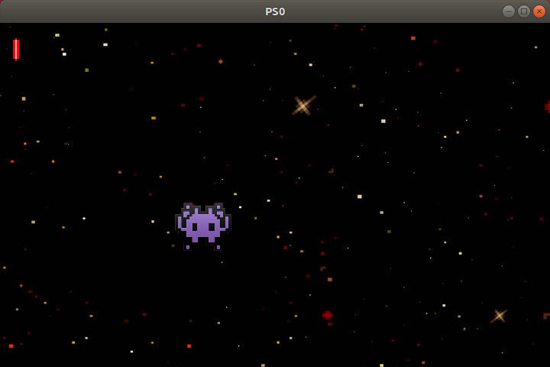

### Makefile

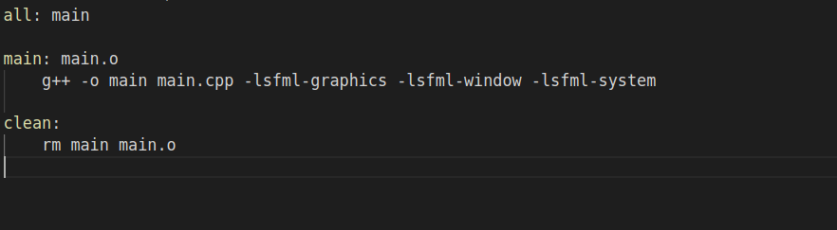

### main.cpp

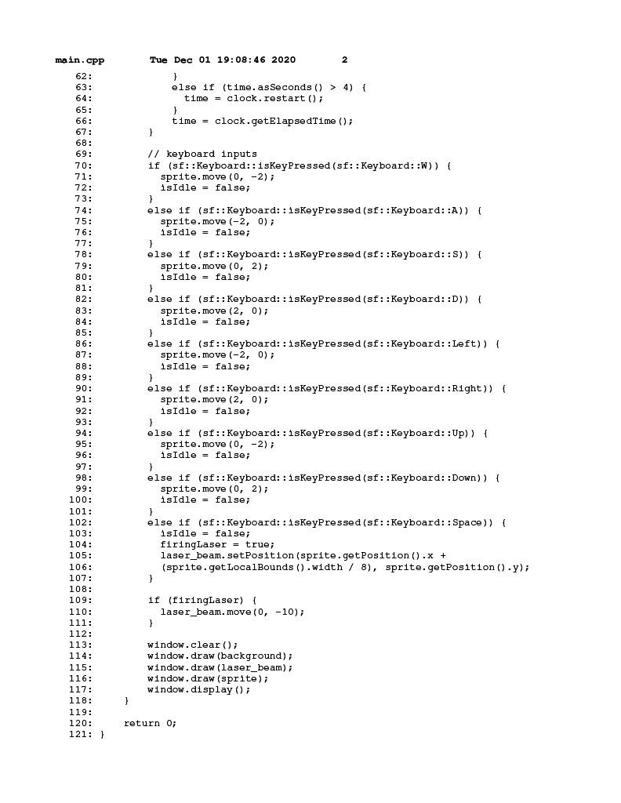

## **PS1** Linear Feedback Shift Register and Image Encoding

This project was split into two parts, PS1a and PS1b. For PS1a, we were asked to implement a Fibonacci linear feedback shift register (LFSR) which would produce pseudo-random bits to be used for image encryption in PS1b. The assignment required the LFSR to take a 16-bit binary seed and XOR the designated tap bits from its current state to generate the new rightmost bit of its next state after shifting each bit once to the left. PS1b would then have a main function to take an image file as input and use the LFSR to encrypt its pixel data and output the result.

**What I Did:**

PS1a - FibLFSR stores a sequence of bits which are shifted to the left and uses tap bits to acquire the rightmost bit. I used a dynamic array of integers to store the supplied seed (input bits). The class has a generate() function which uses step() as a helper function to step through the LFSR. For this part of the assignment I used the Boost C++ libraries to run test cases on the FibLFSR class, this is documented in test.cpp. I made sure to test that both the step() and generate() functions produced the expected output, I also tested for an exception where a supplied seed was shorter/longer than the required 16 bits for the register.

PS1b - PhotoMagic takes three command line arguments, the input filename, output filename, and a 16-bit binary seed. Once the command has been entered, a FibLFSR object is created and the transform() function is called on the image which encrypts or decrypts images by XORing pixel data with bits from the register. The program also checks to make sure all command line arguments are entered correctly. In the SFML display loop, two new windows will display both the original and the encrypted/decrypted image.

**Key Algorithms, Data Structures, and OOP Designs:**

The FibLFSR class is a container for a dynamic array which has a size equal to the length of the binary seed passed to it upon construction, however for this assignment an exception is thrown if the string is not exactly 16 bits long. The PhotoMagic class will handle any exceptions that may be thrown by FibLFSR. Since FibLFSR has dynamically allocated memory, the appropriate copy/move/destructor functions are present in the class.

**What I Learned:**

This assignment was a good exercise in reviewing C++ programming techniques I had learned previously, such as the rule of 5, operator overloading, exception handling, and SFML. This was also the first time I used header files to define classes and have them linked to my other source code. On top of that I also learned how to use the Boost libraries to easily run unit tests on my FibLFSR class while it was still in development.

### Encryption Process

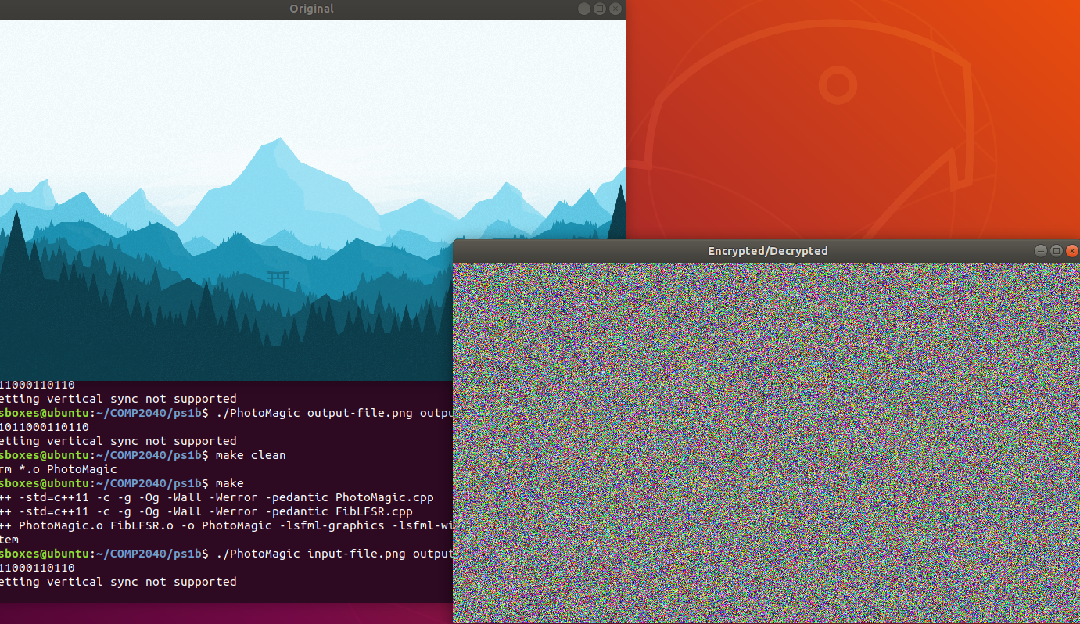

### Decryption Process

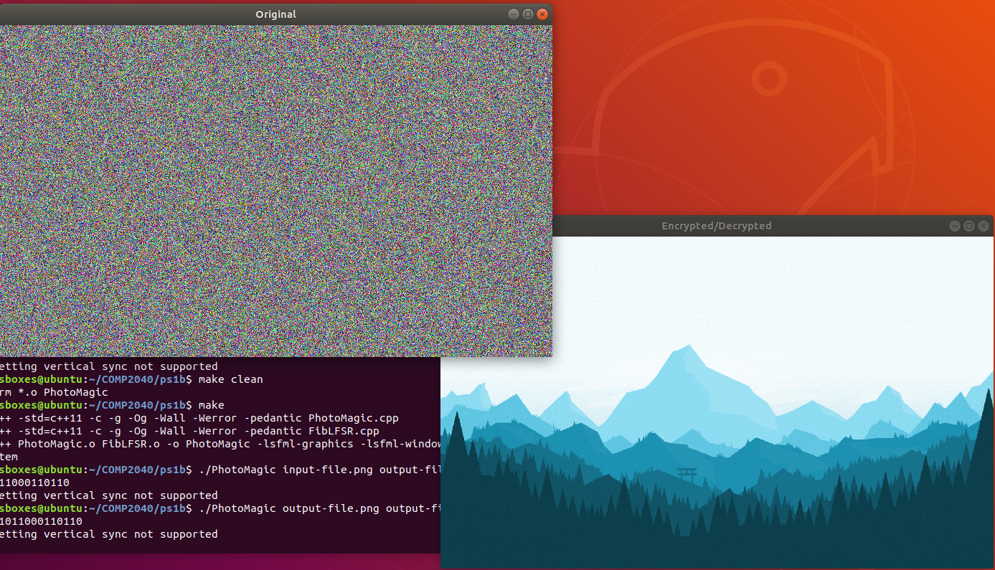

### Makefile

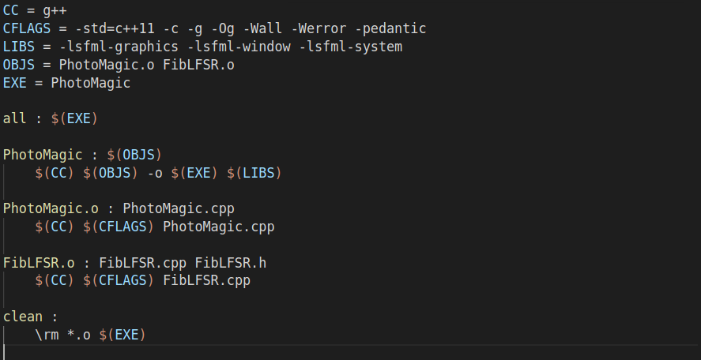

### FibLFSR.h

### 

### FibLFSR.cpp

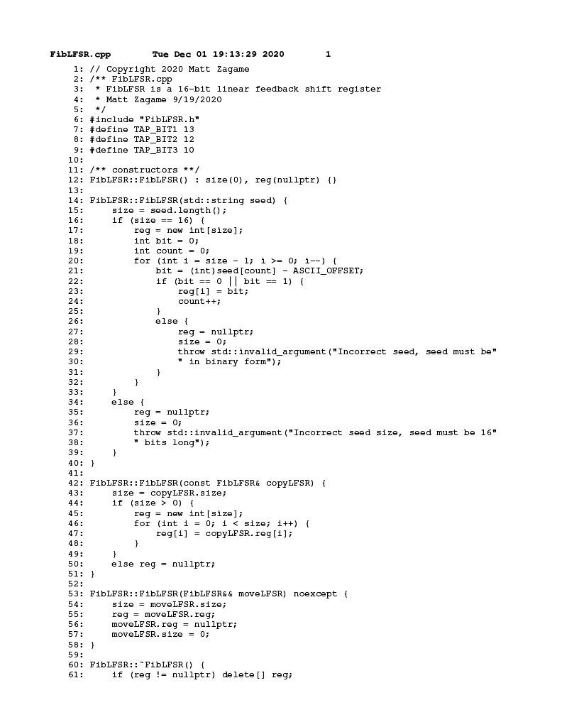

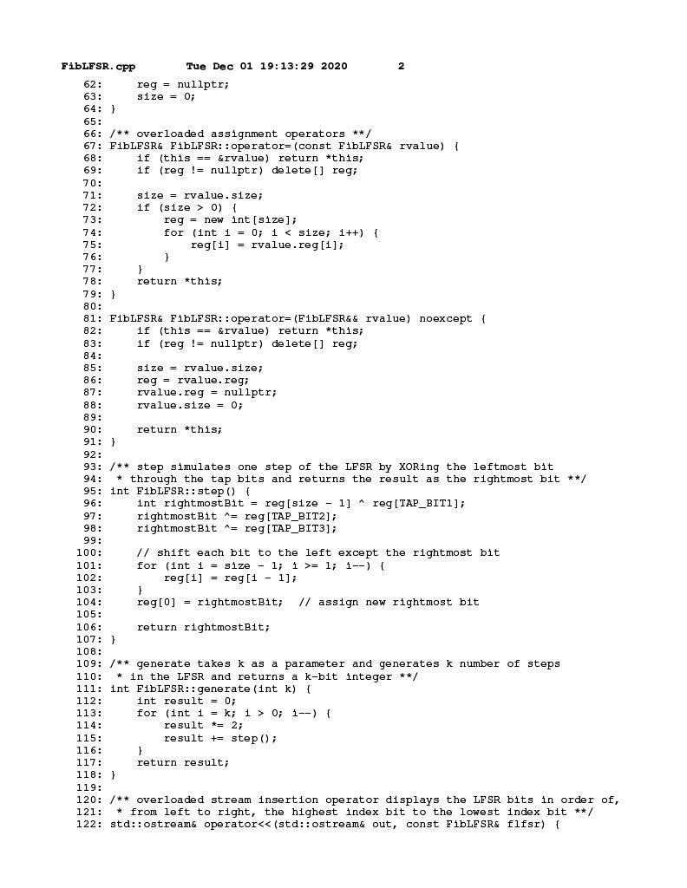

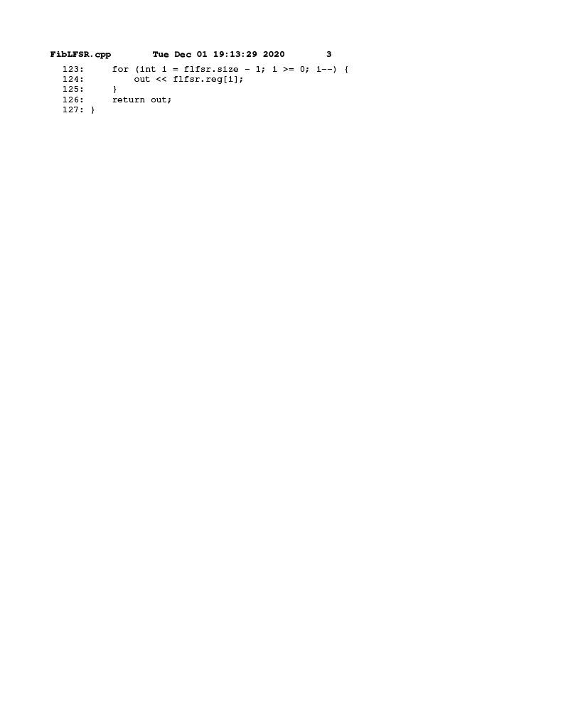

### PhotoMagic.cpp

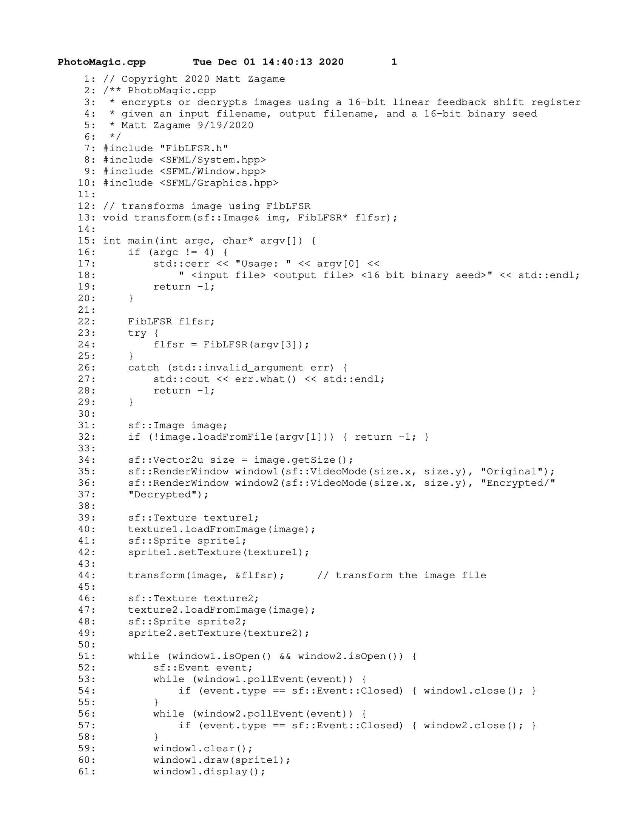

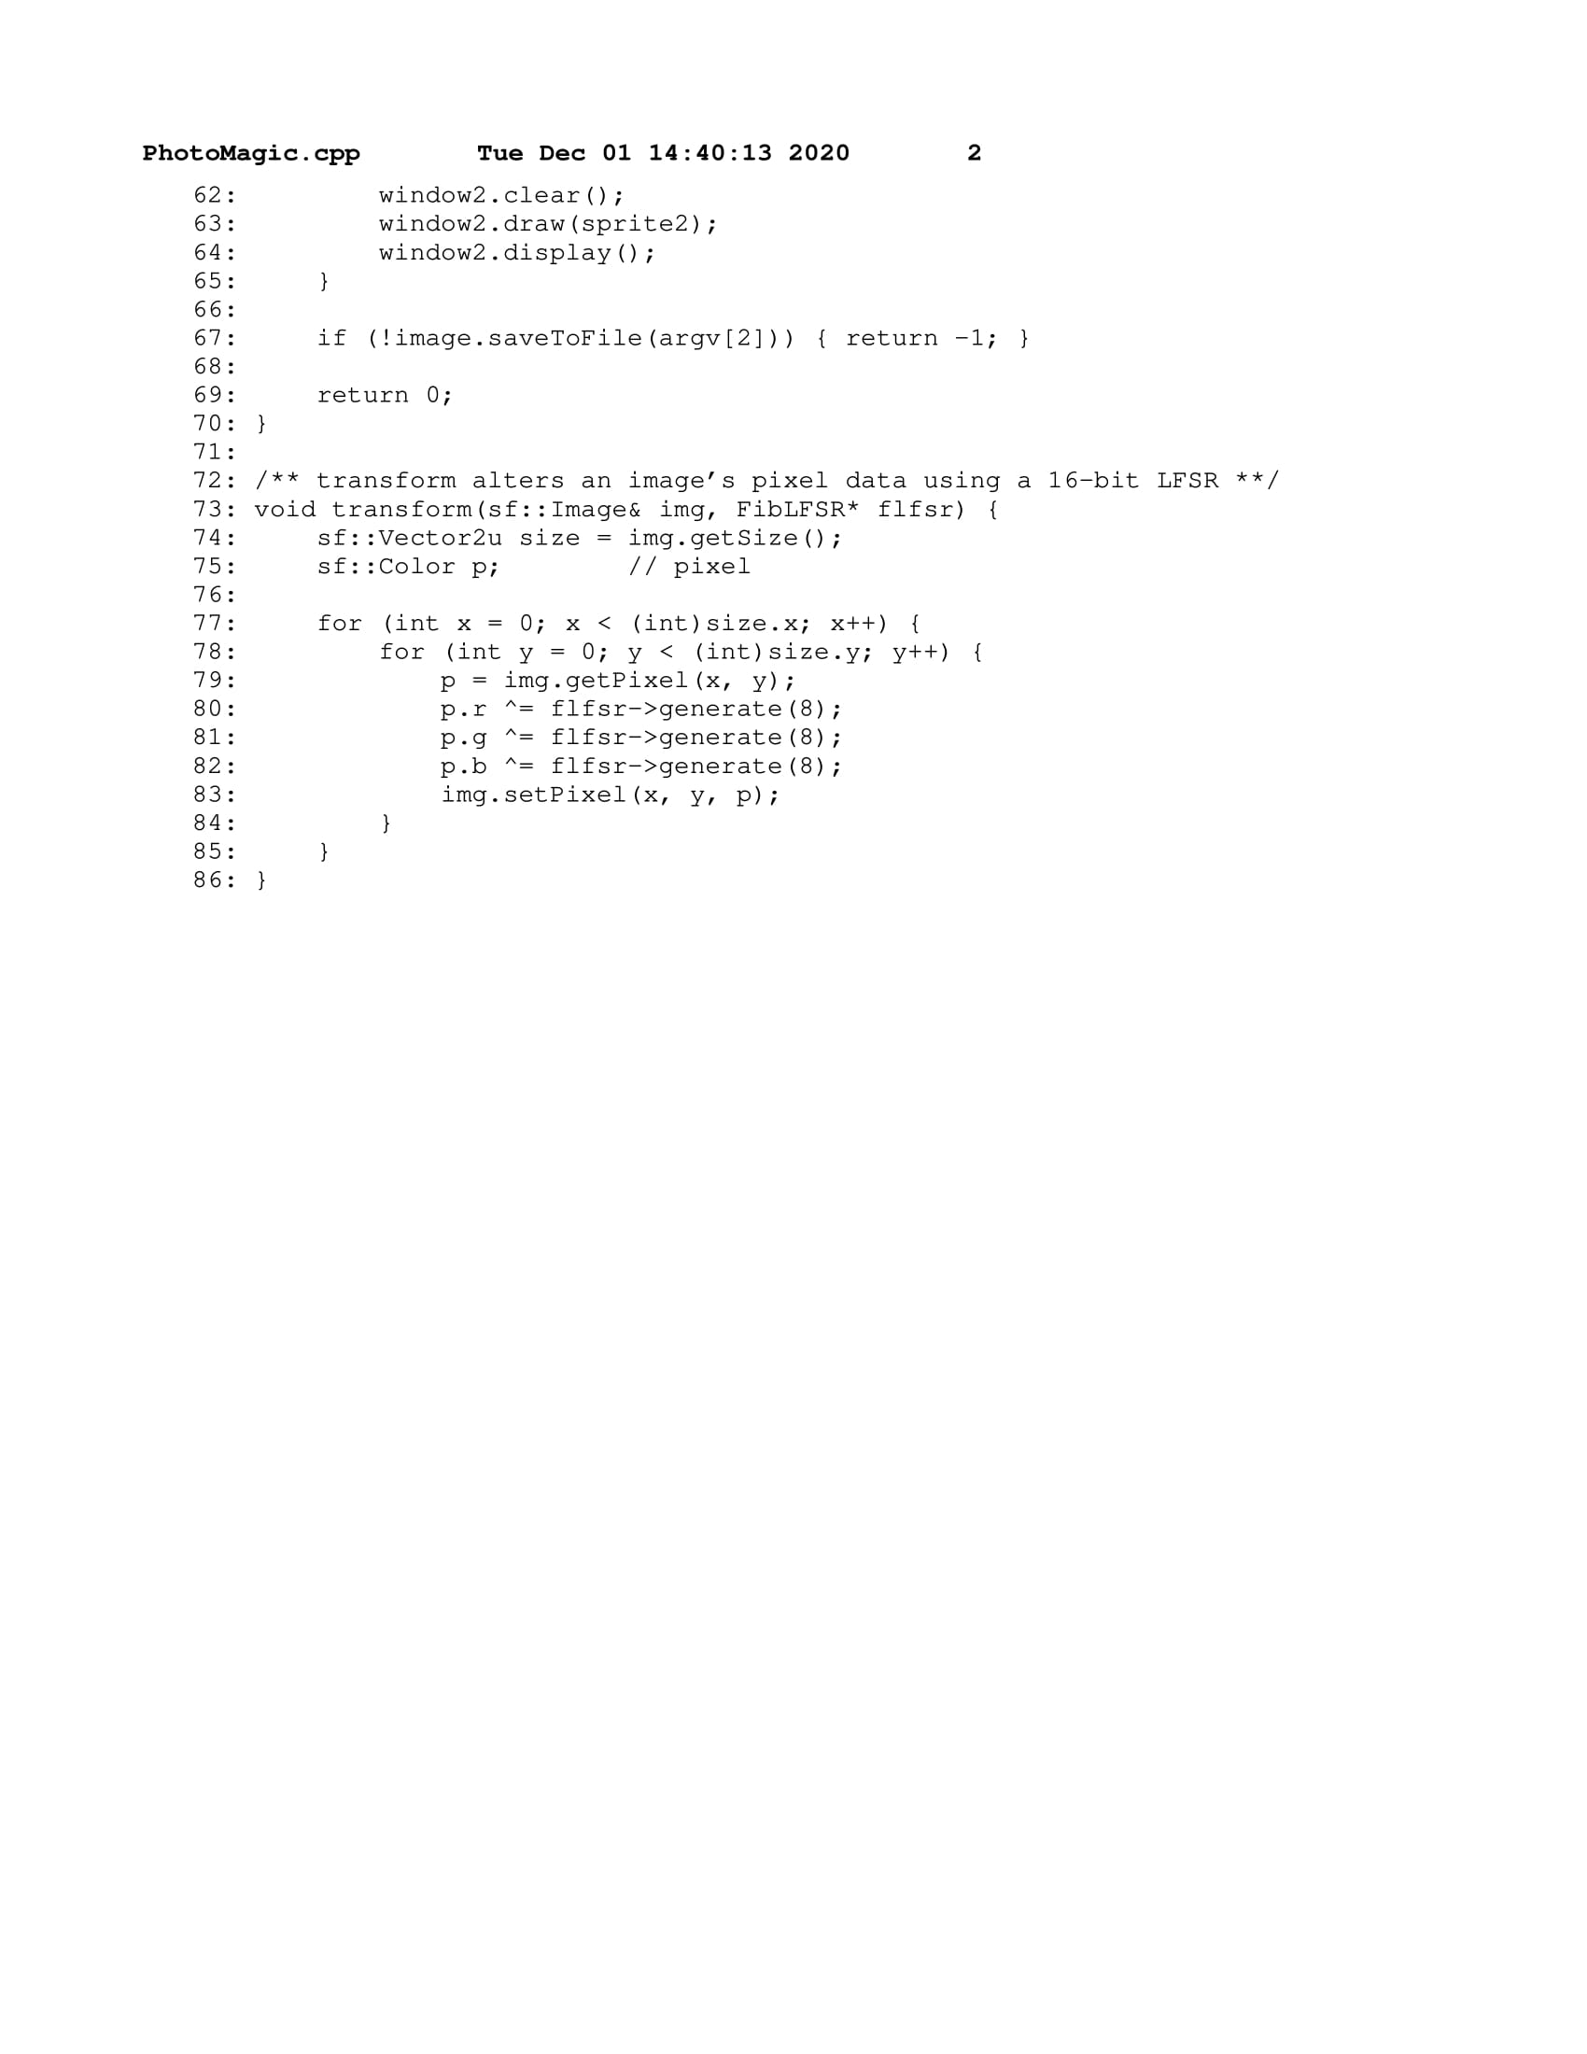

### test.cpp

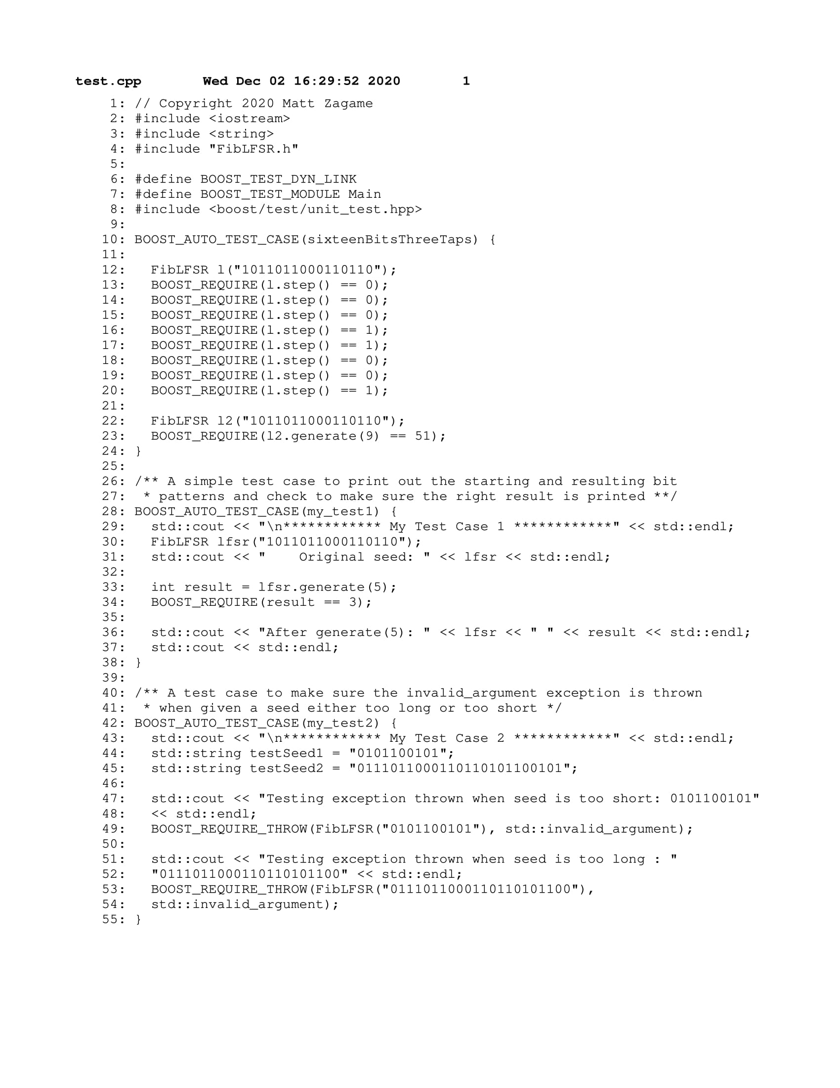

## **PS2** N-Body Simulation

The goal of this assignment was to simulate the effect of pairwise forces on particles in a universe. This assignment had two parts, PS2a and PS2b. The first half of the assignment involved creating a display of our galaxy using two classes, one to represent each planet and one to manage each of the planets. The objective of the first part was just to make sure planets could be read from a text file and that planets were displayed correctly in the SFML window. The second half of the assignment involved using the proper physics calculations to simulate the effects of pairwise force. A main function was required to take input in the form of total time of the simulation, the amount of time in one step of the simulation, and the input file with each planet’s information.

**What I Did:**

PS2a - NBody displays celestial bodies in a universe using the information found in the provided text file. This file contains the number of planets to display and the radius of the universe on the first two lines. Each subsequent line contains a planet's x position, y position, x and y velocities, mass, and image filename. I overloaded the insertion operator in the Universe class so that the program could use input redirection from the provided text file to store the planets in the universe. I then wrote the main function which would create the universe given the text file as a command line argument.

PS2b - NBody simulates the effect of gravitational forces on several CelestialBody objects in the Universe. The user can run NBody using any of the universe text files found in the provided directory. For this portion of the assignment I implemented the step() function in Universe which calculates pairwise forces and increments the simulation by a given amount of time in seconds. The main function of NBody is responsible for displaying the particles in the universe and managing the time loop.

**Key Algorithms, Data Structures, and OOP Designs:**

Overloading the insertion operator in the Universe class allows for input redirection from a file to set up the planets for simulation. Both CelestialBody and Universe are sf::Drawable so that they may be drawn to the window. Each CelestialBody is instantiated using a std::unique_ptr and stored in a std::vector within the Universe class. The planets are then drawn in a loop in main using the draw function on each CelestialBody in the vector. The step() function in Universe is where the bulk of the calculations are performed for this program.

**What I Learned:**

I learned quite a bit in this assignment. For starters, this was the first C++ program where I used smart pointers to initialize objects. I also was able to output the final position information of the simulation to a text file at the end of the main function using fstream. Outside of C++, I also learned a lot about the physics involved in the N-Body simulation using the leapfrog finite difference approximation scheme.

### PS2a Demo

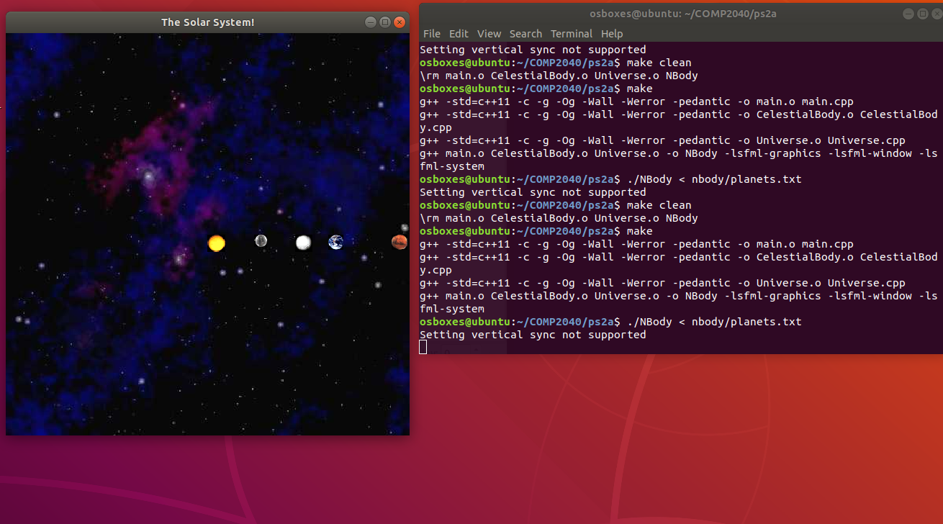

### Makefile

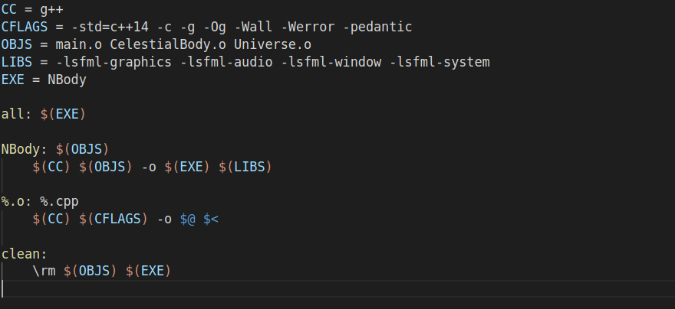

### CelestialBody.h

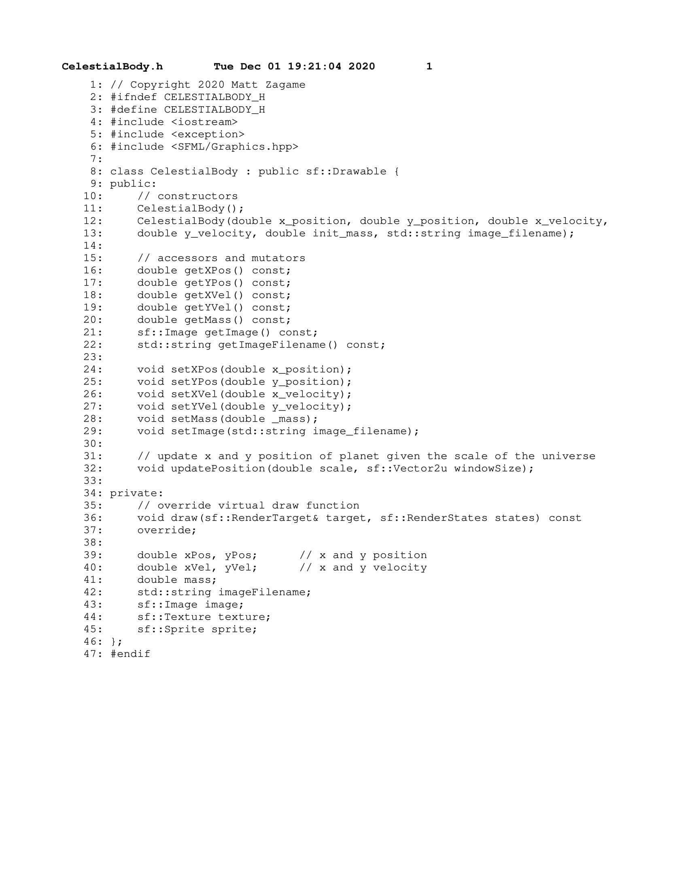

### CelestialBody.cpp

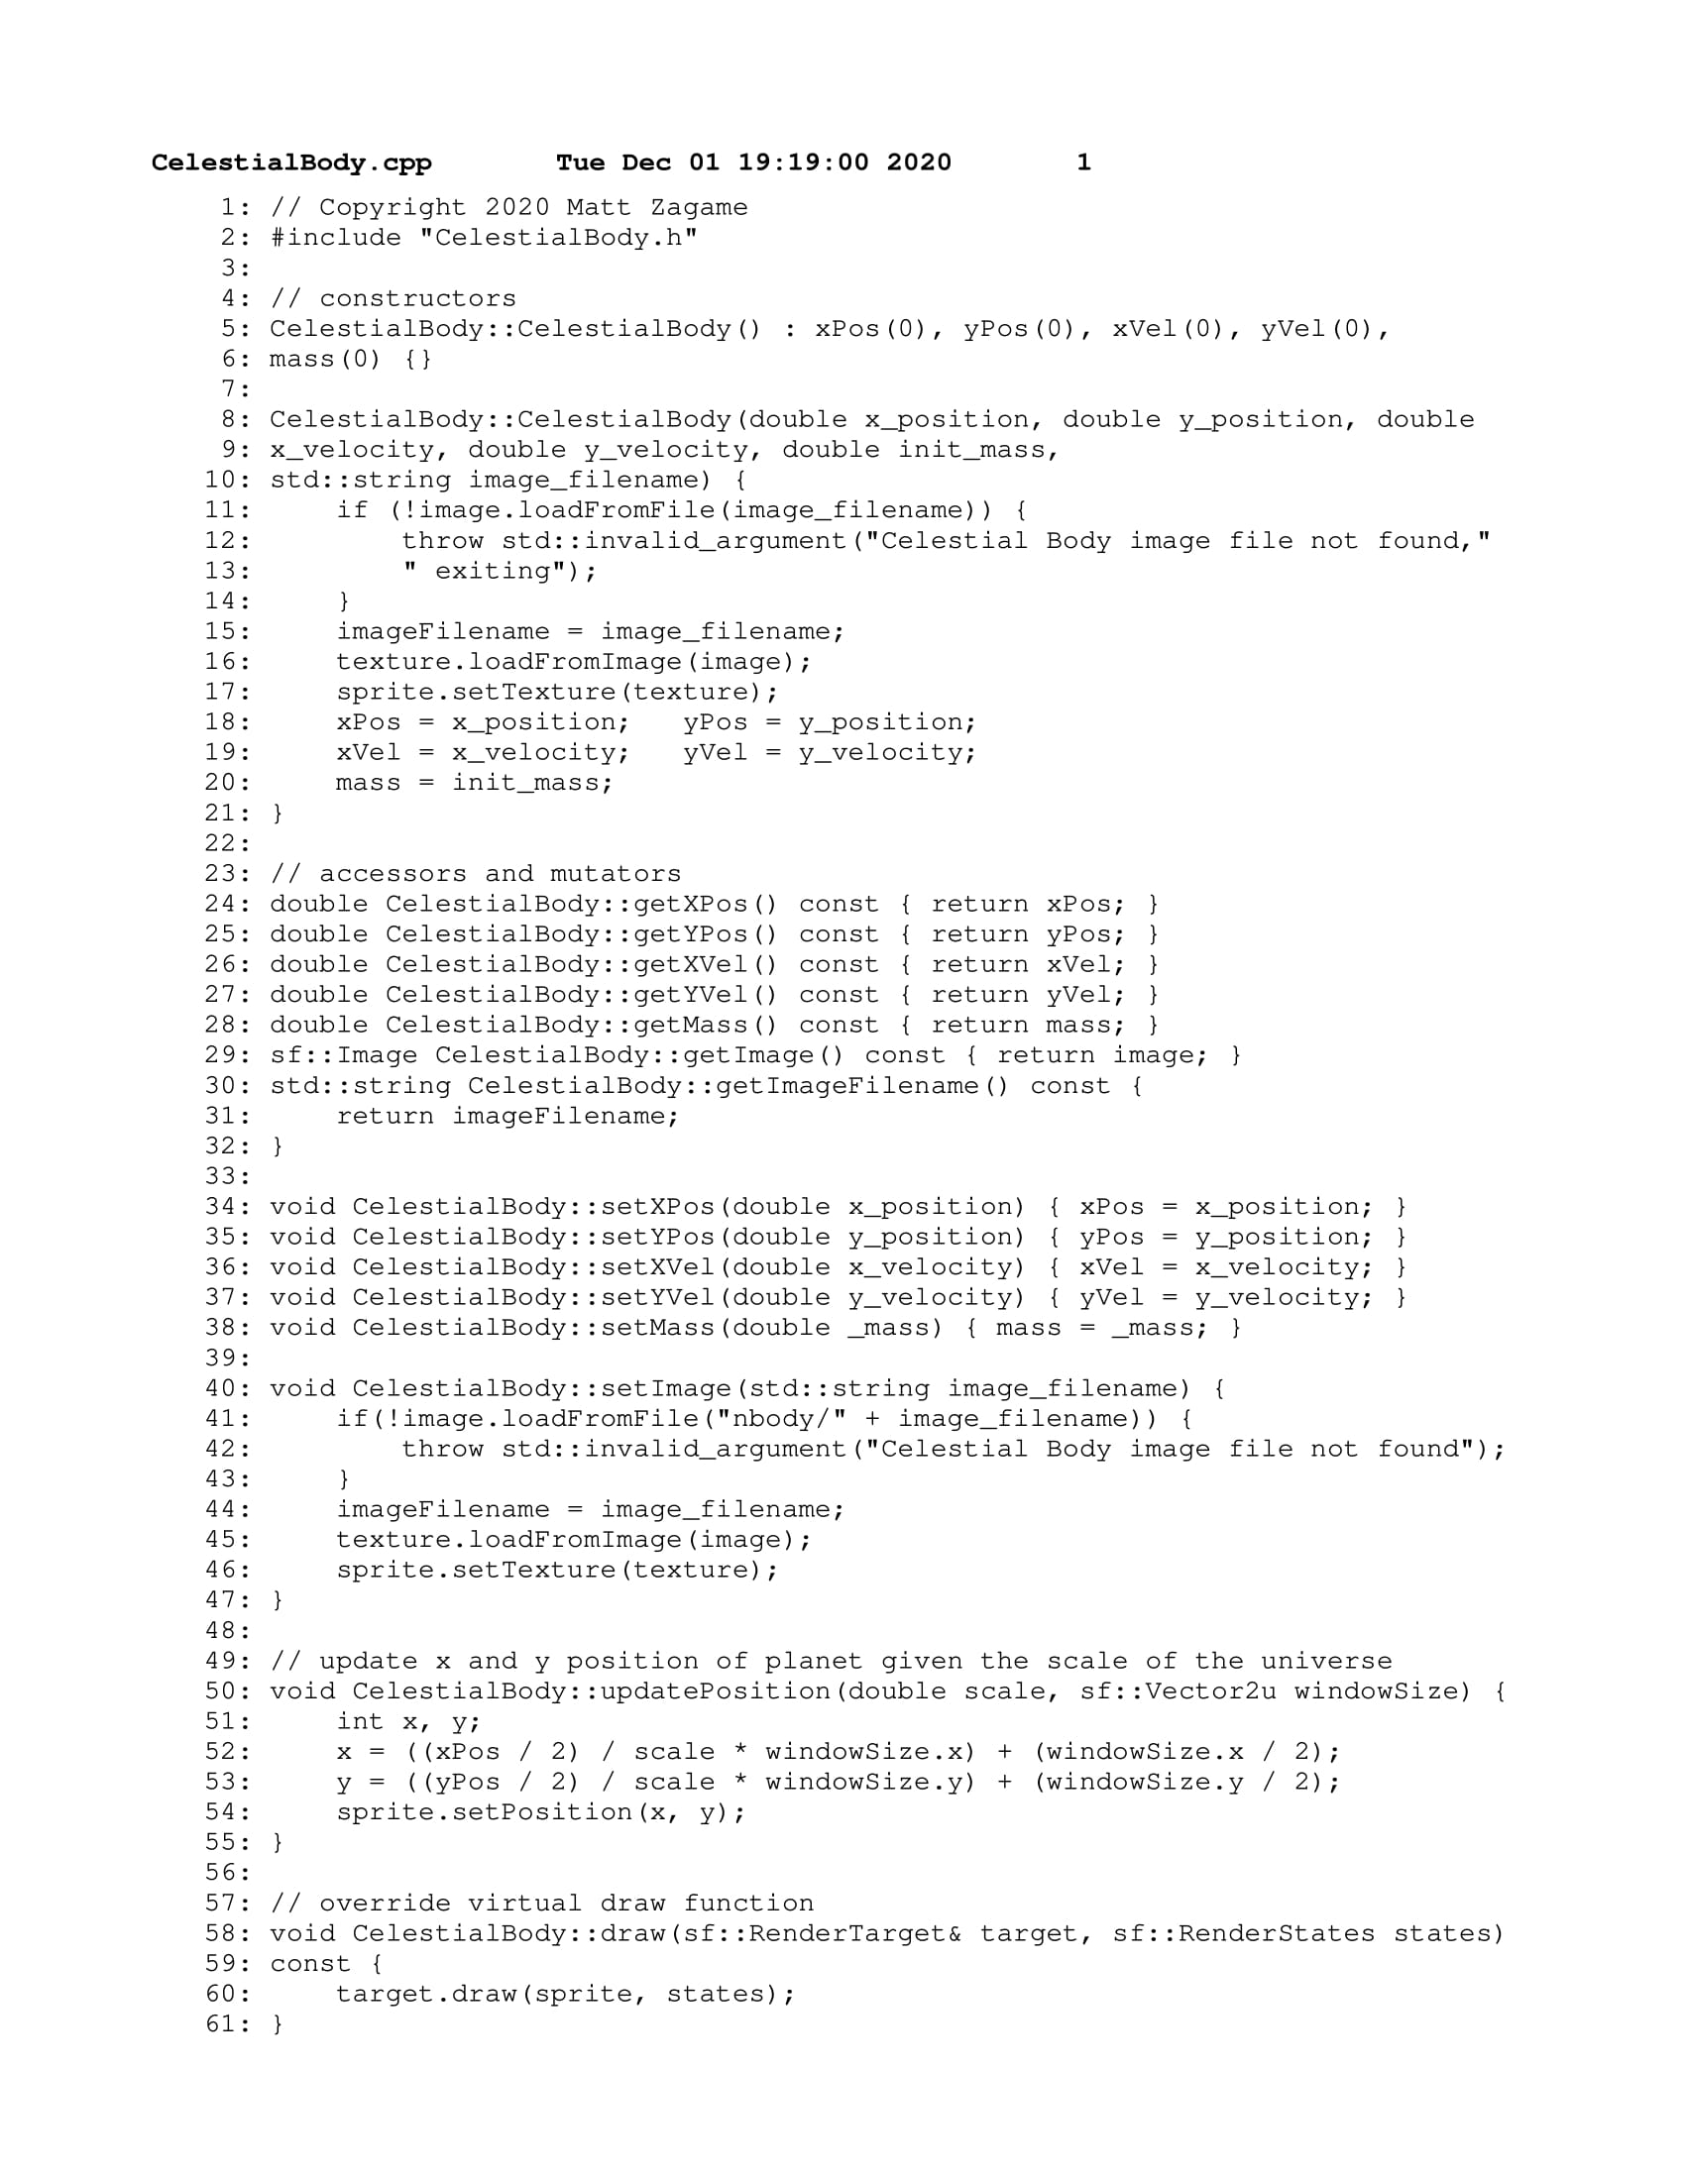

### Universe.h

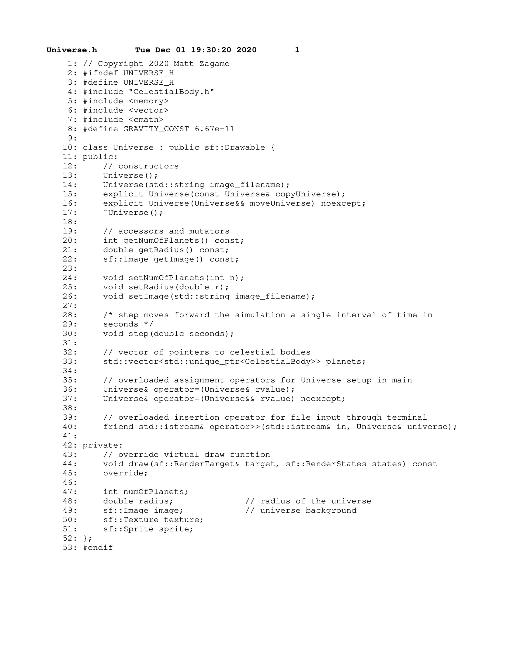

### Universe.cpp

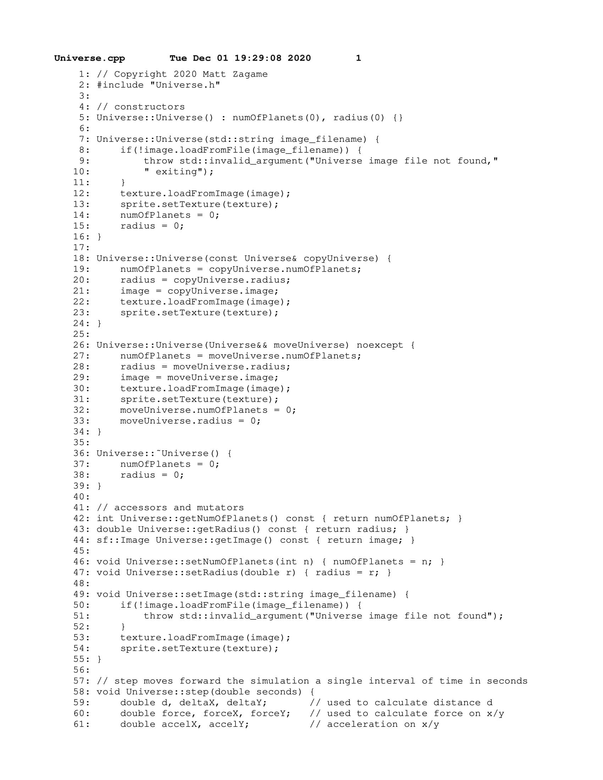

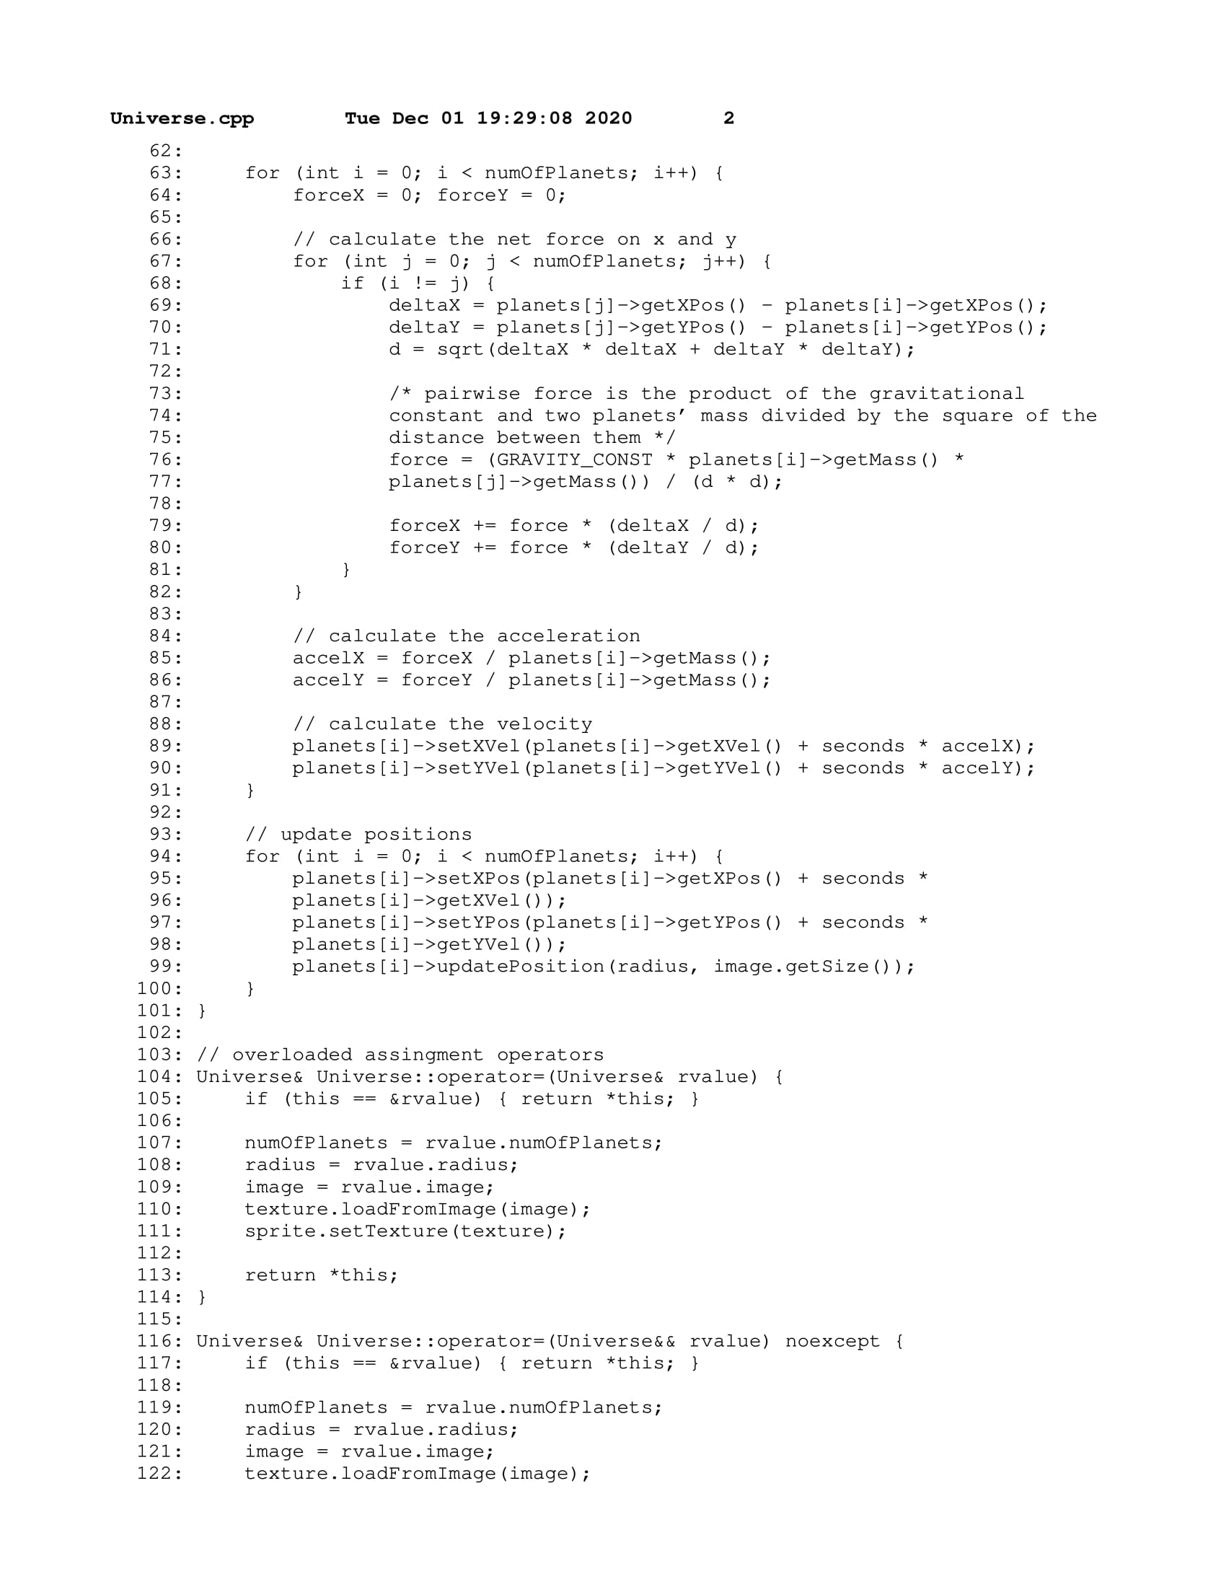

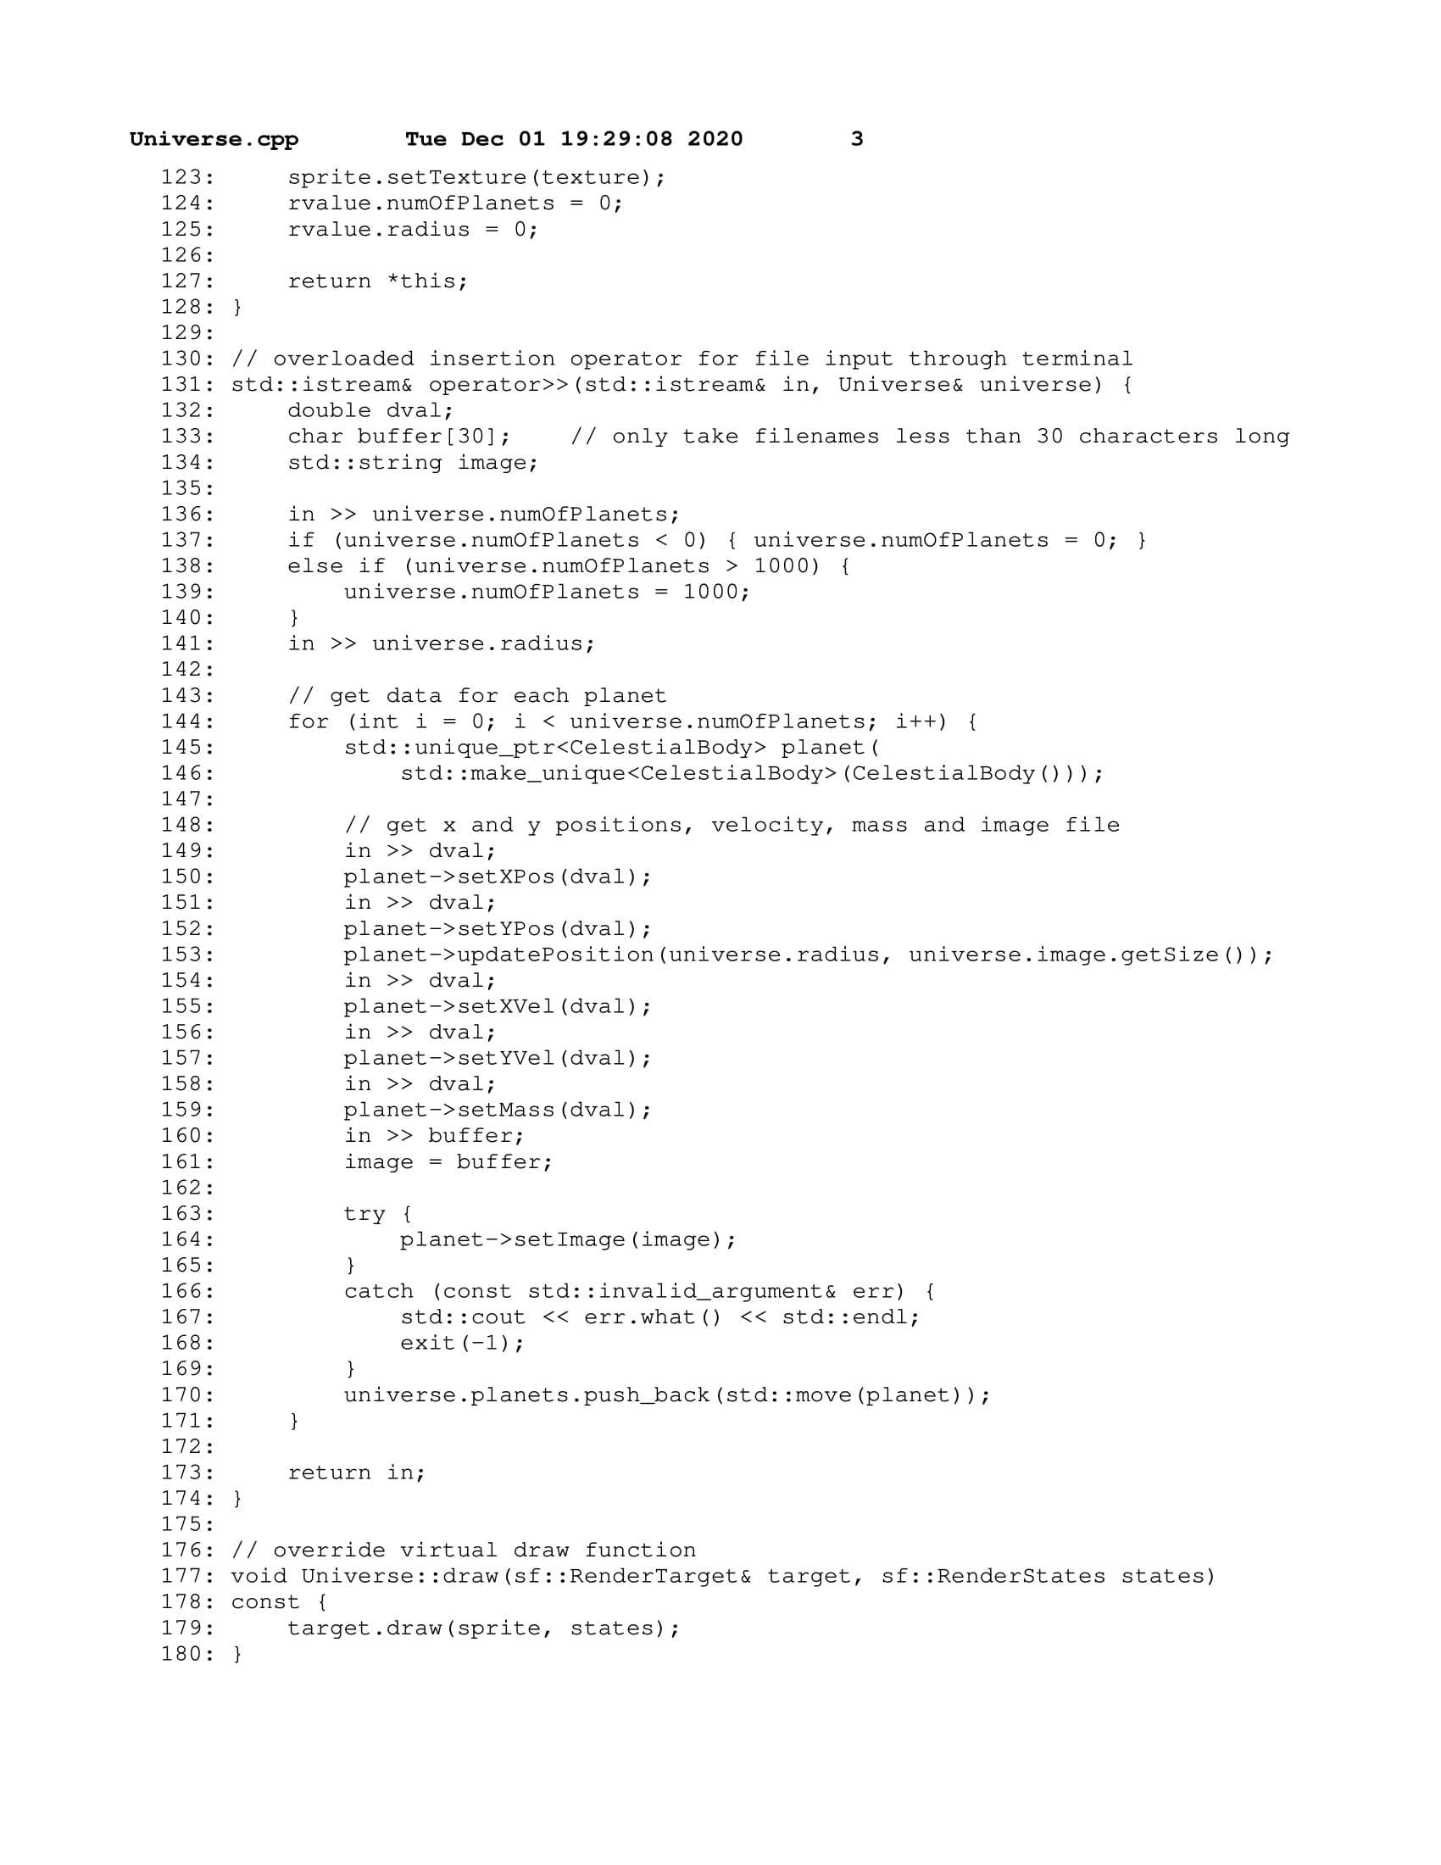

### main.cpp

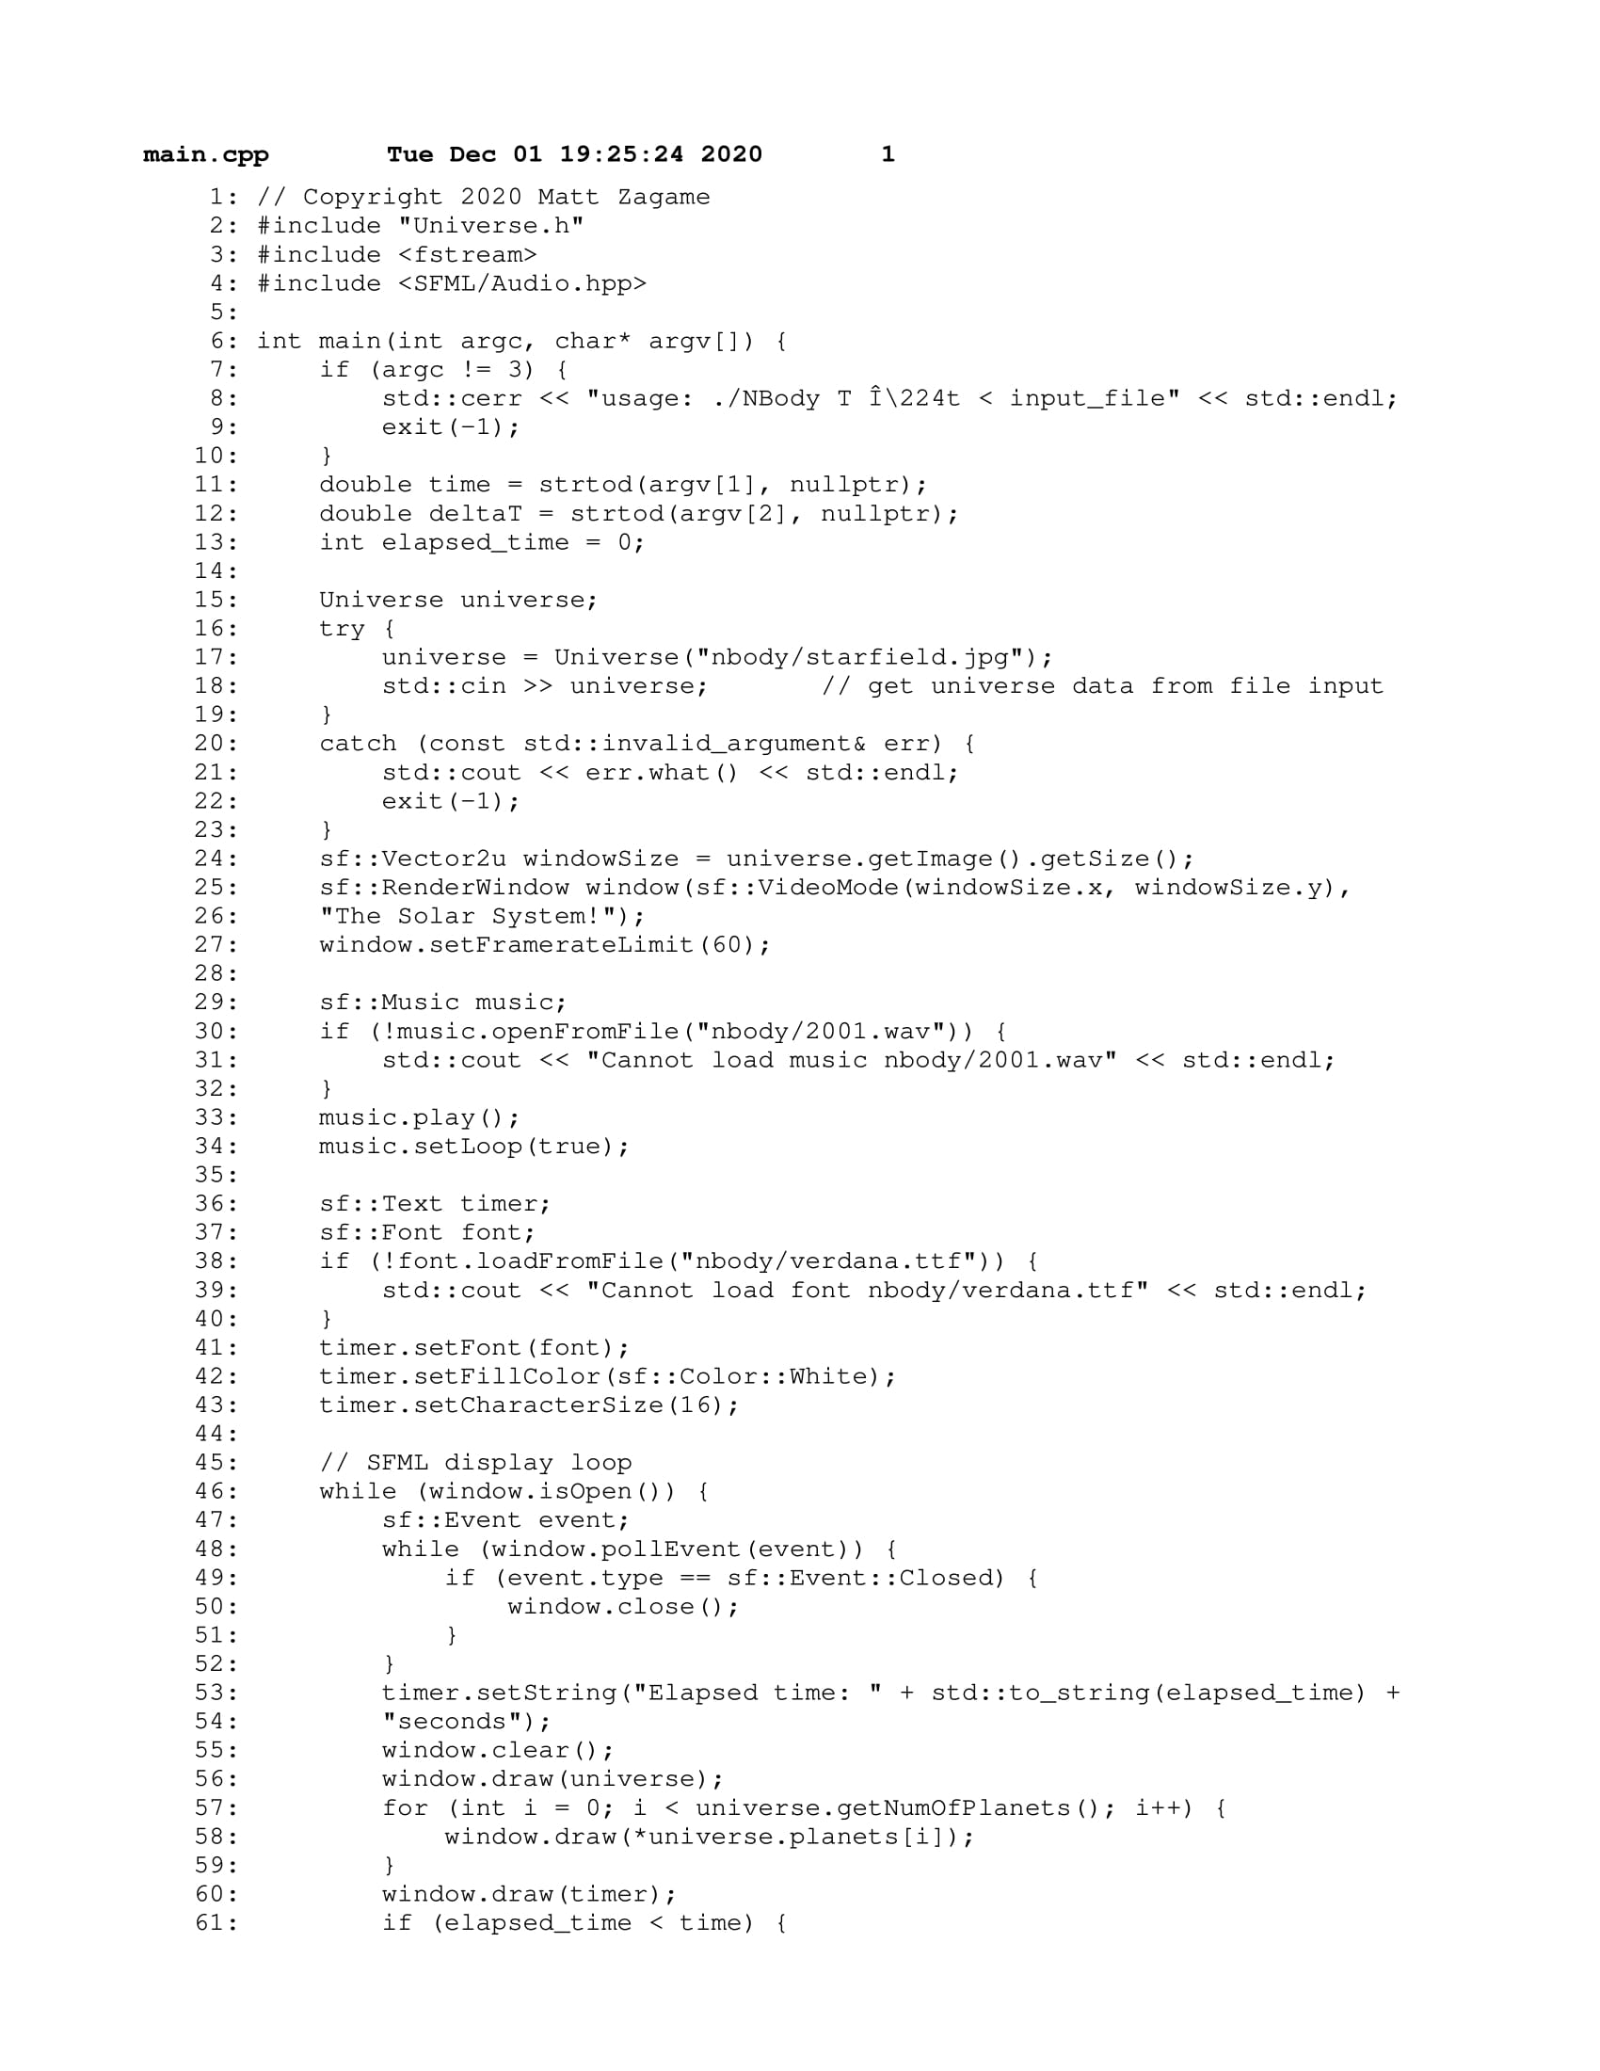

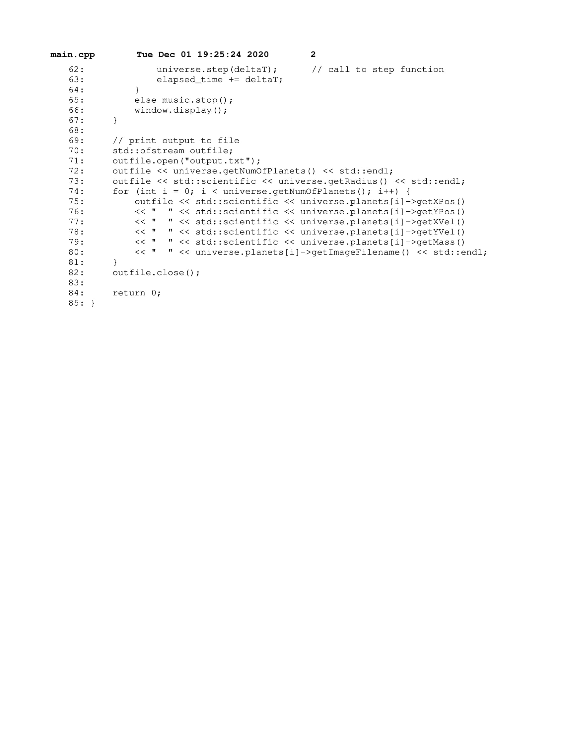

## **PS3** Karplus-Strong Guitar Simulation

This assignment focused on simulating a plucked guitar string sound using the Karplus-Strong algorithm. The assignment was split into two parts, PS3a and PS3b. In PS3a, we were to implement the class CircularBuffer which would be used to maintain a ring buffer feedback mechanism. PS3b would then implement the class StringSound which would initialize a CircularBuffer with N samples based on a sample rate of 44,100Hz and a given frequency. These frequencies would be associated with key presses in the main function and output using SFML audio.

**What I Did:**

PS3a - CircularBuffer emulates a ring buffer feedback mechanism using an array of type int16_t which stores N samples of a vibration. The class implements the array as a queue, with functions such as enqueue and dequeue, to work with the Karplus-Strong algorithm. The CircularBuffer constructor and its queue functions include exception handling which I tested using Boost libraries in test.cpp.

PS3b - StringSound takes a frequency and creates a CircularBuffer of length equal to sample rate / frequency. The function pluck() which fills the buffer of a string sound with random values in the Int16 range to simulate noise. The function tic() is responsible for advancing the sound’s buffer to its next state, and the sample() function returns the first sample from the buffer. The main function first creates a vector of Int16 vectors of each string sounds’ samples, which is then loaded into a vector of sf::SoundBuffers, which are lastly loaded into a vector of sf::Sounds. Inside the SFML display loop, a sound will be played based on the corresponding key pressed.

**Key Algorithms, Data Structures, and OOP Designs:**

StringSound uses CircularBuffer as a dynamic array and thus each class had dynamic memory allocation and required copy/move/destructor functions. Exceptions were used in both classes for several functions. For example, the StringSound(frequency) constructor has one exception that prevents construction with a frequency of 0. StringSound handles exceptions thrown by CircularBuffer when dynamically allocating memory for the buffer during construction and when using the CircularBuffer functions in its own functions.

**What I Learned:**

I learned a bunch about how digital audio is streamed by using the Karplus-Strong algorithm and how to work with audio using SFML. I also learned about the mersenne twister random number generator which I used to implement the pluck() function. This was also the first assignment that I wrote that would conform to Google’s style guidelines for C++.

### Makefile

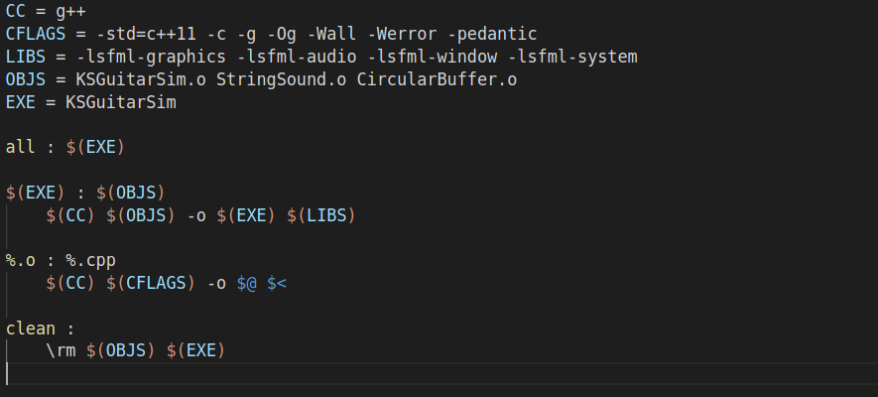

### CircularBuffer.h

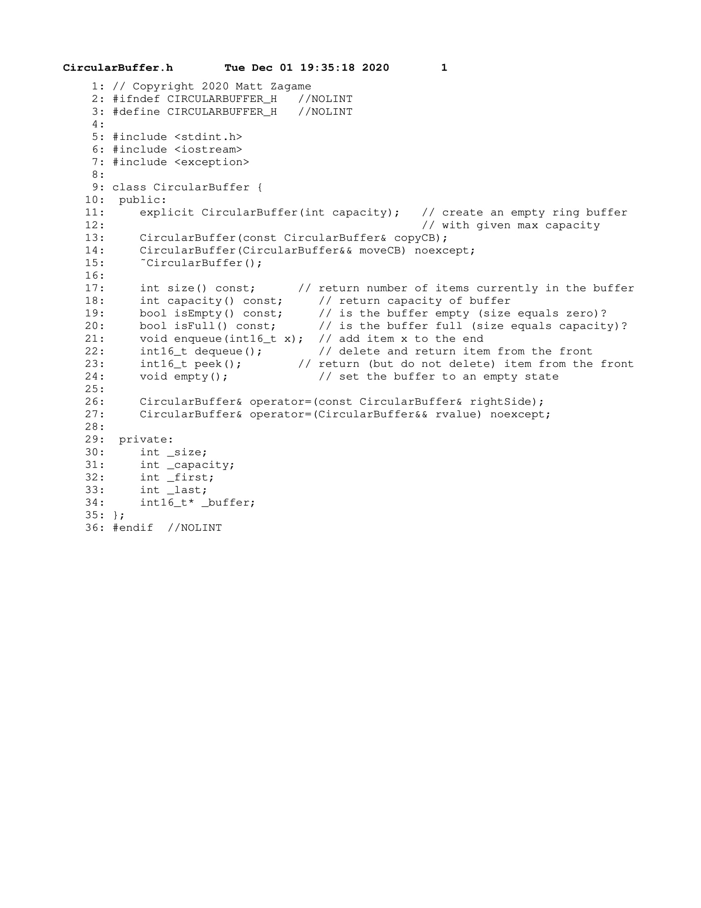

### CircularBuffer.cpp

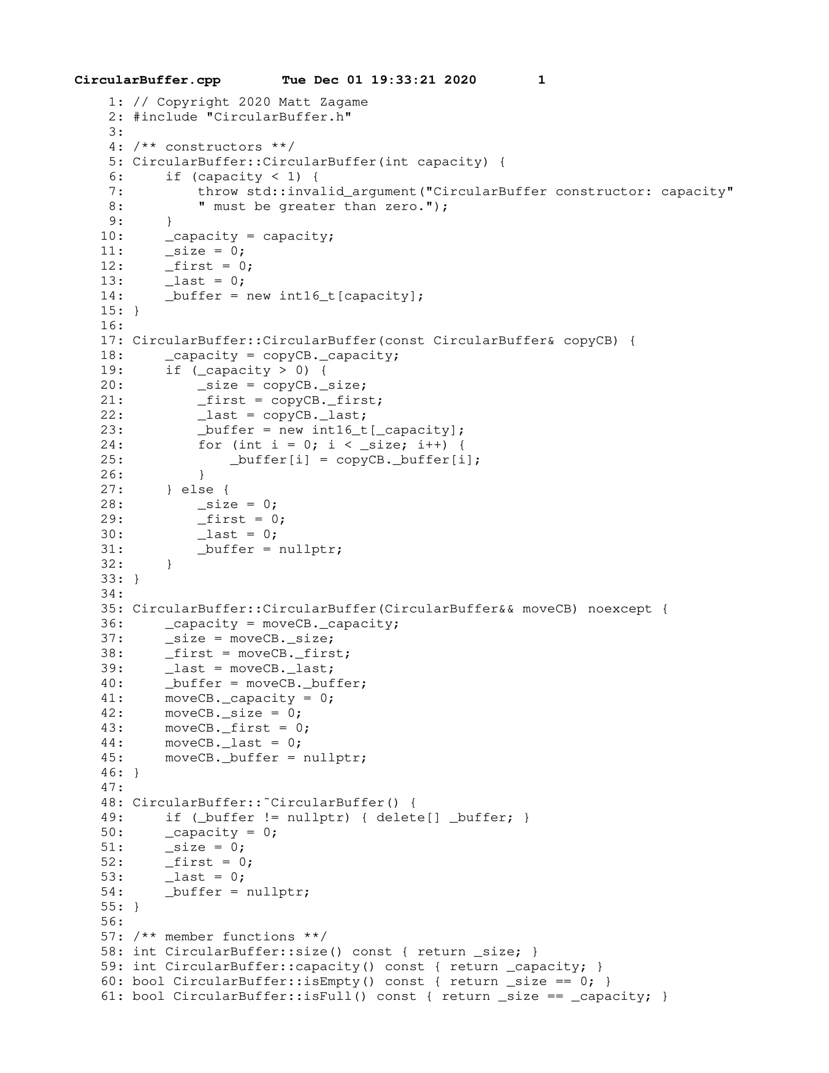

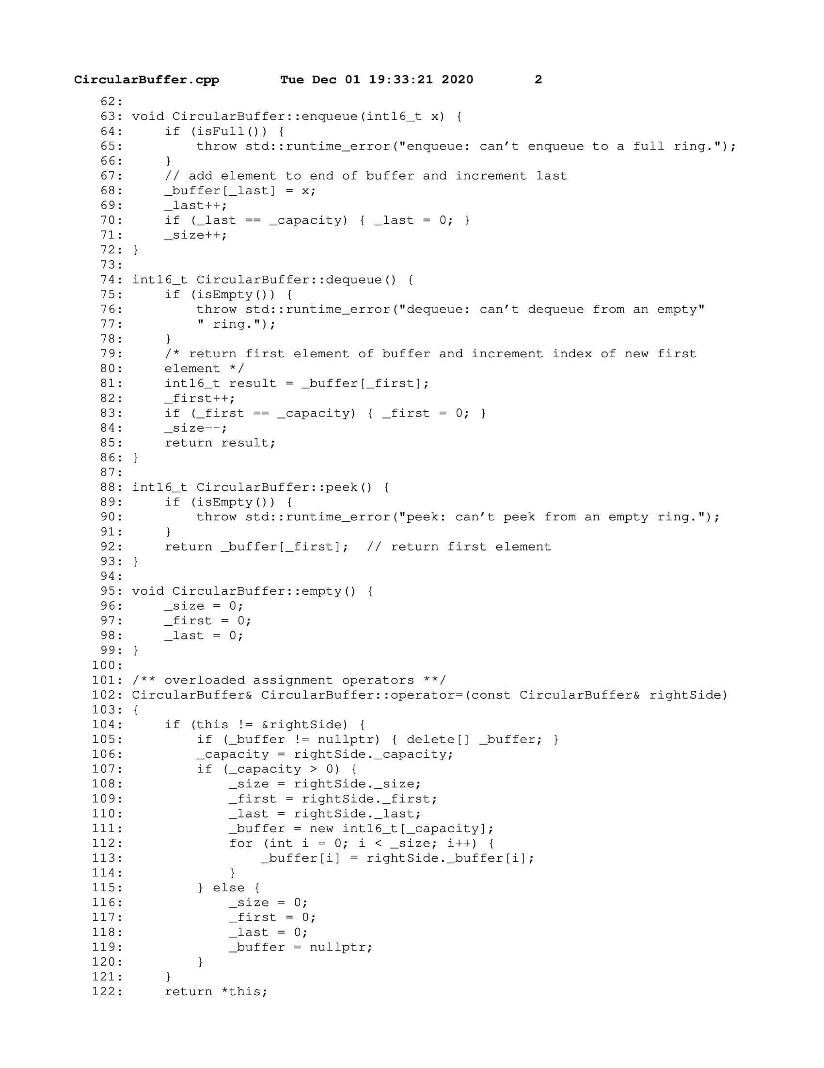

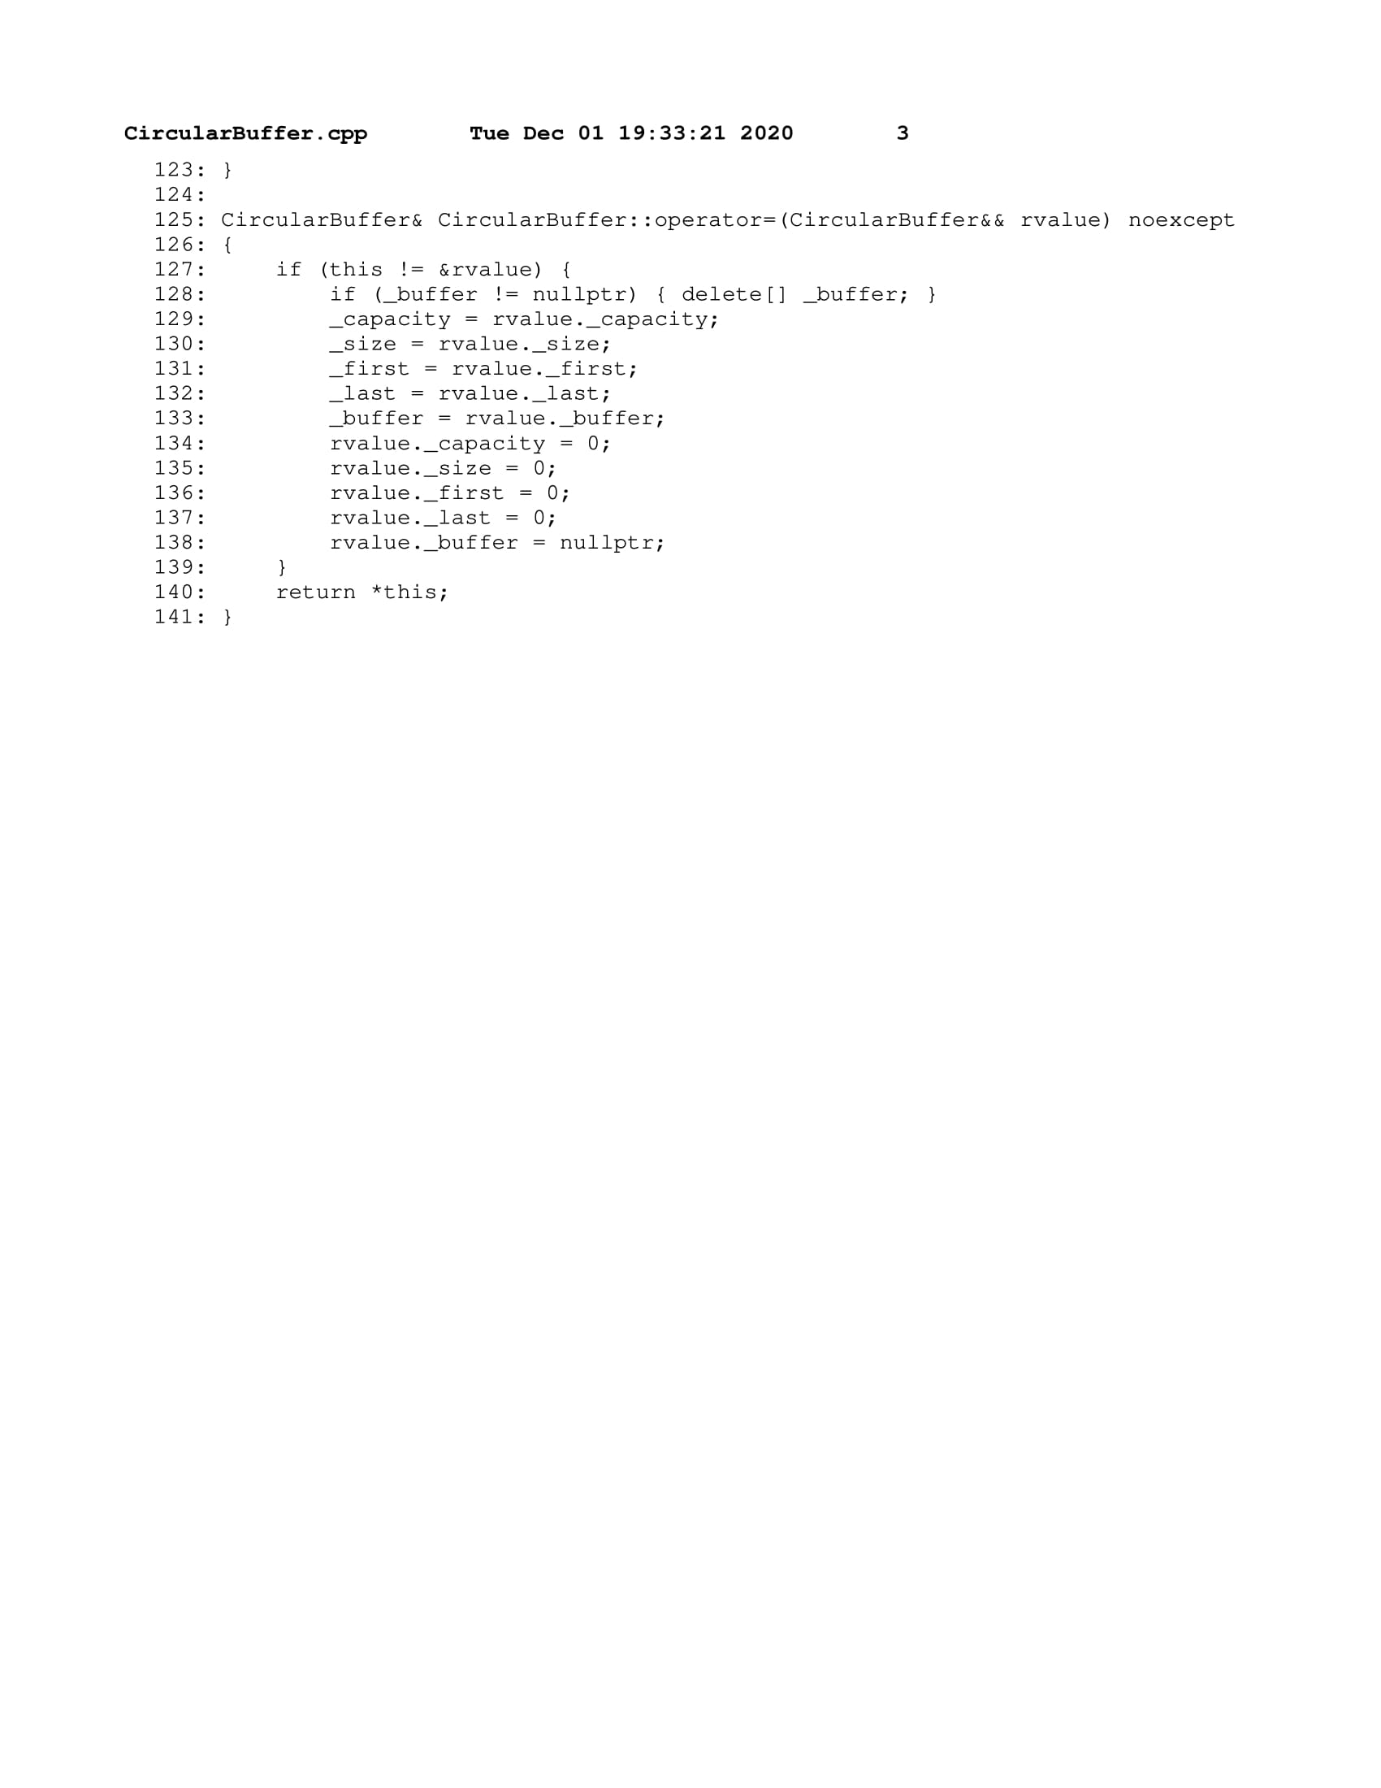

### StringSound.h

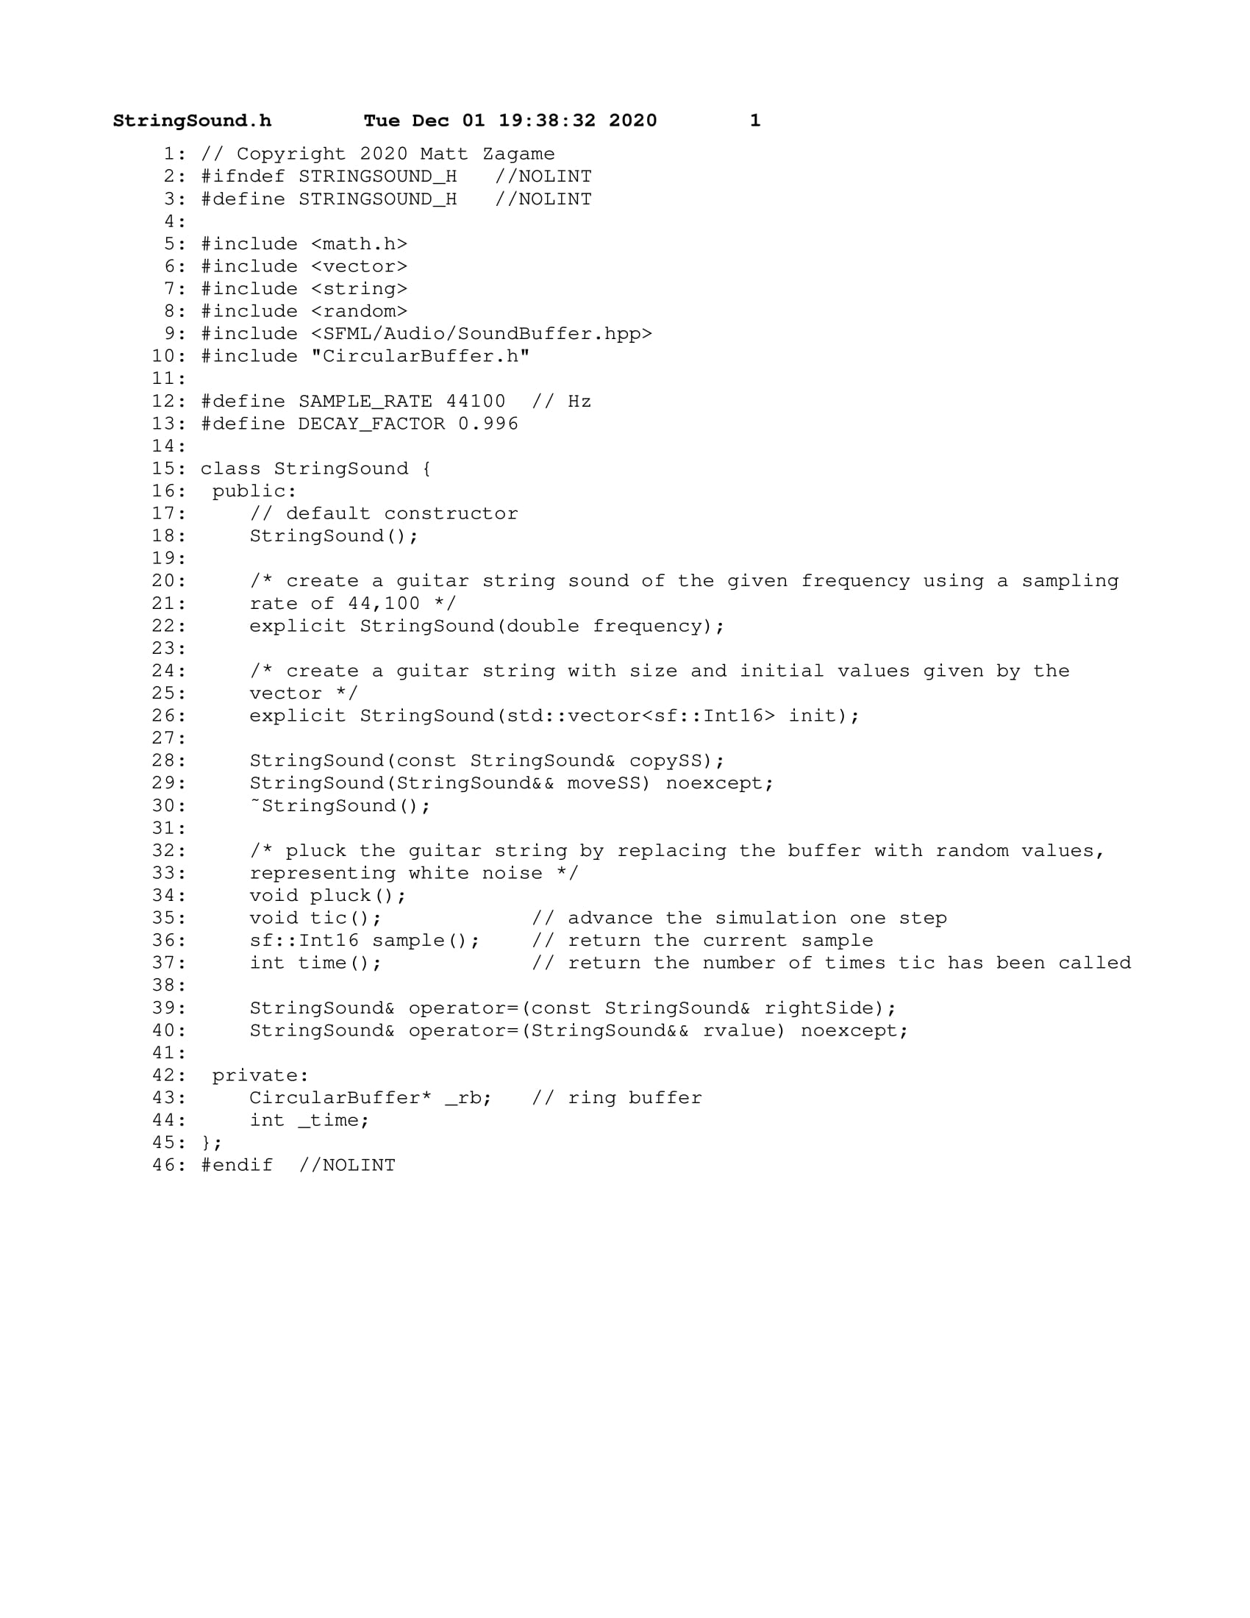

### StringSound.cpp

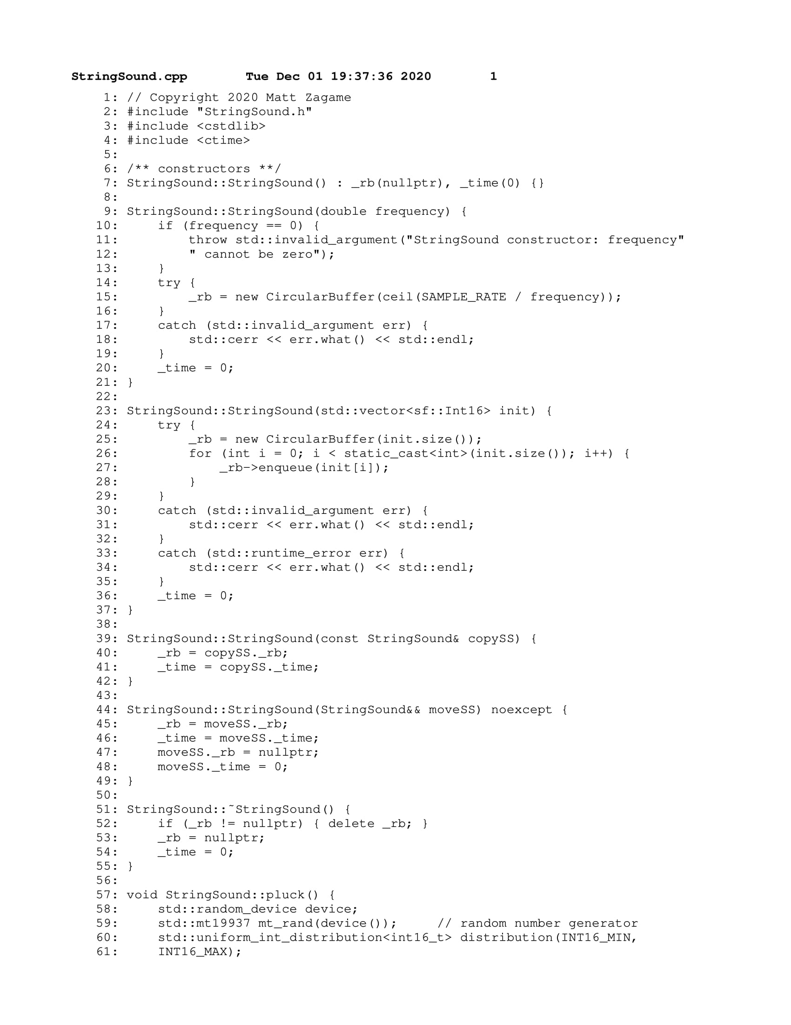

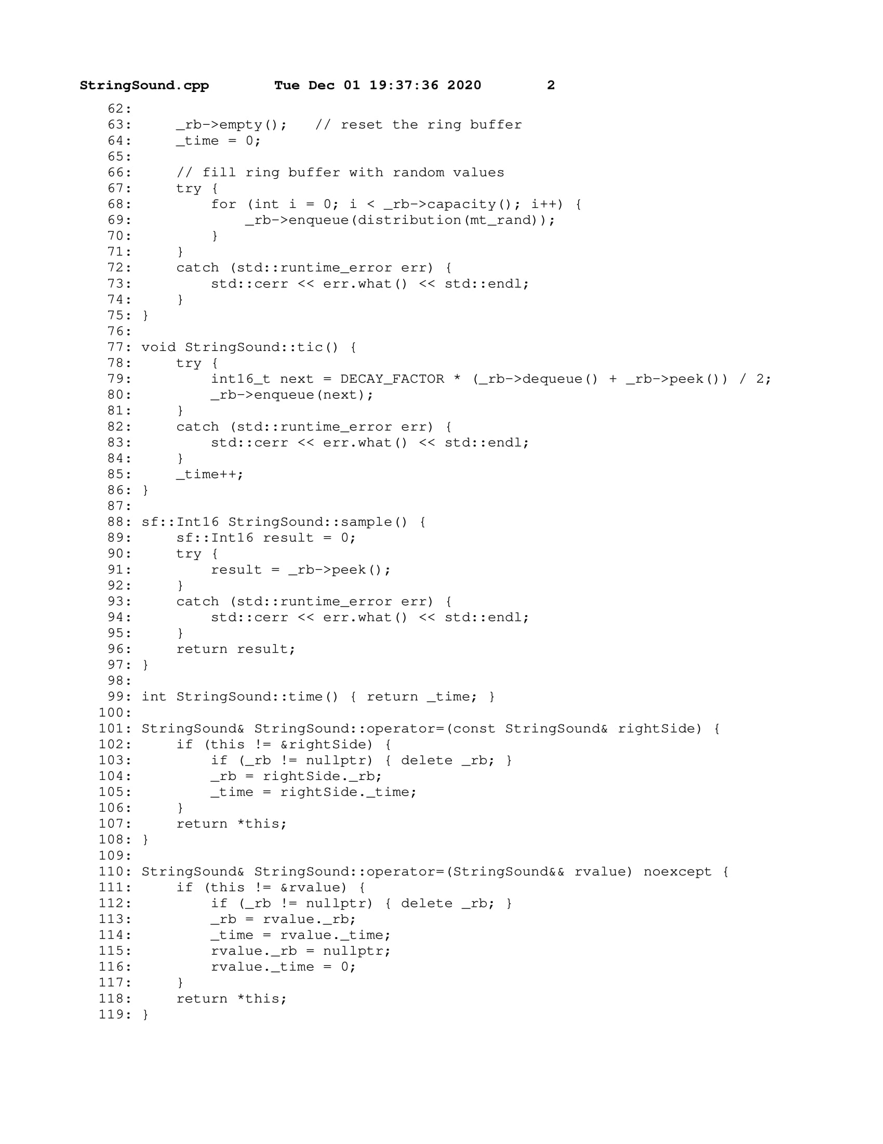

### KSGuitarSim.cpp

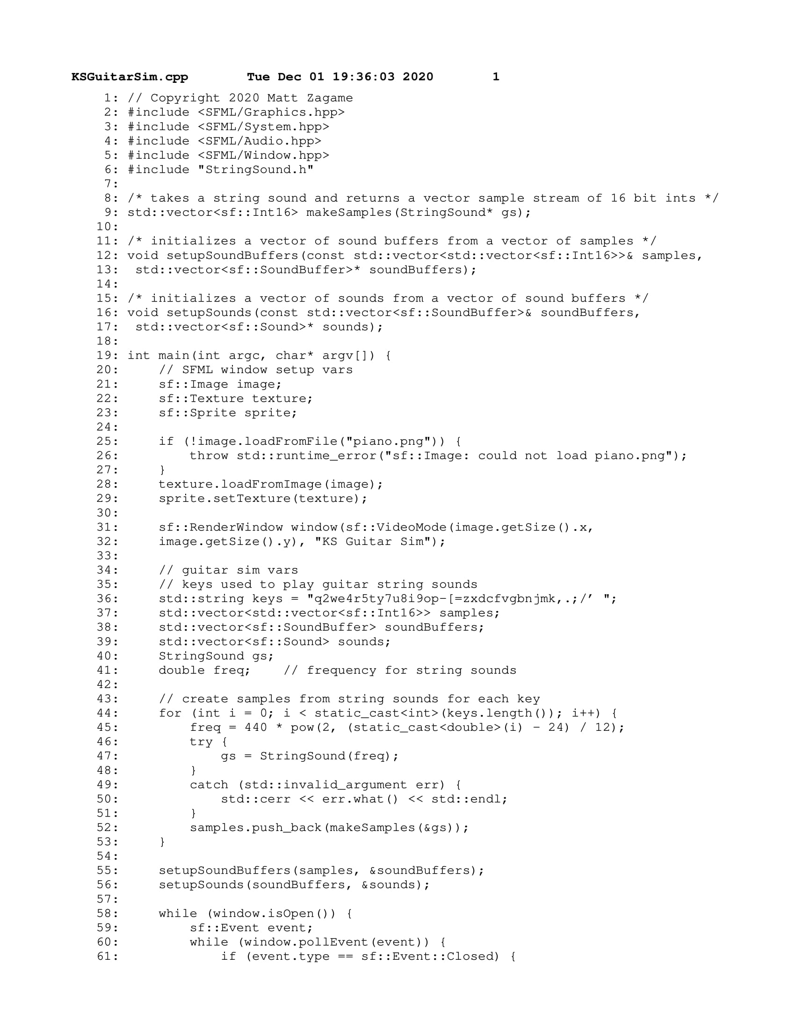

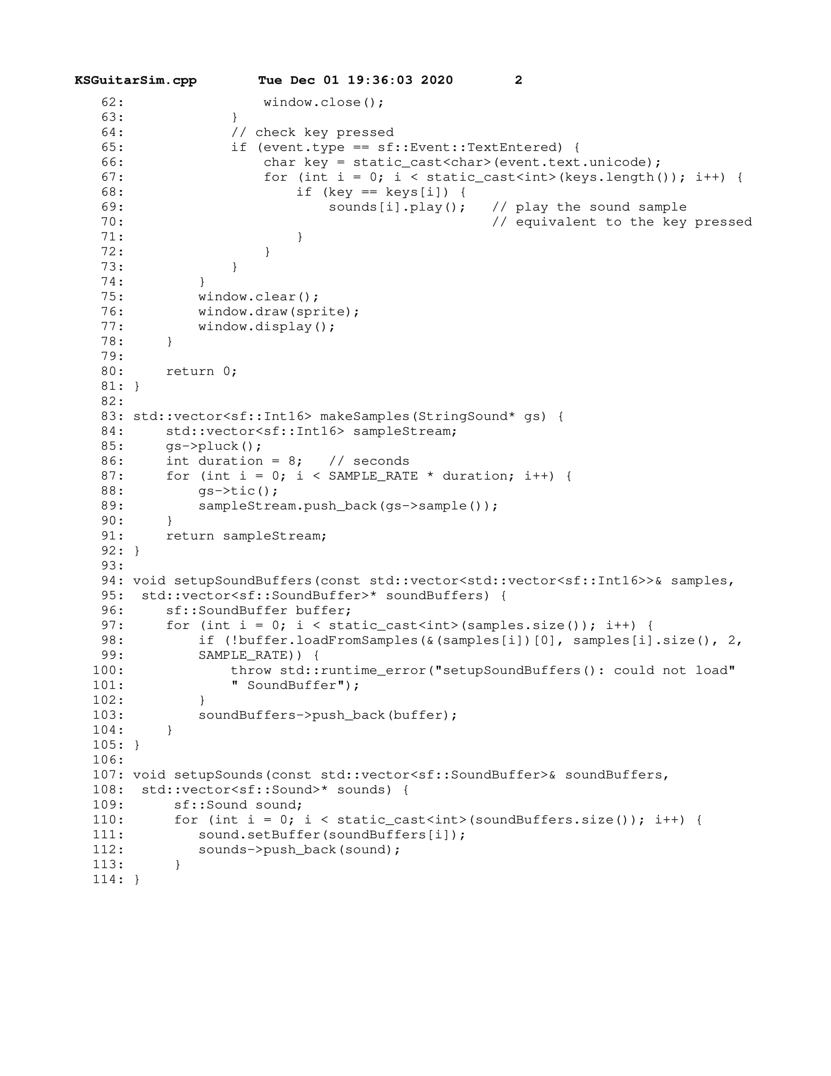

### test.cpp

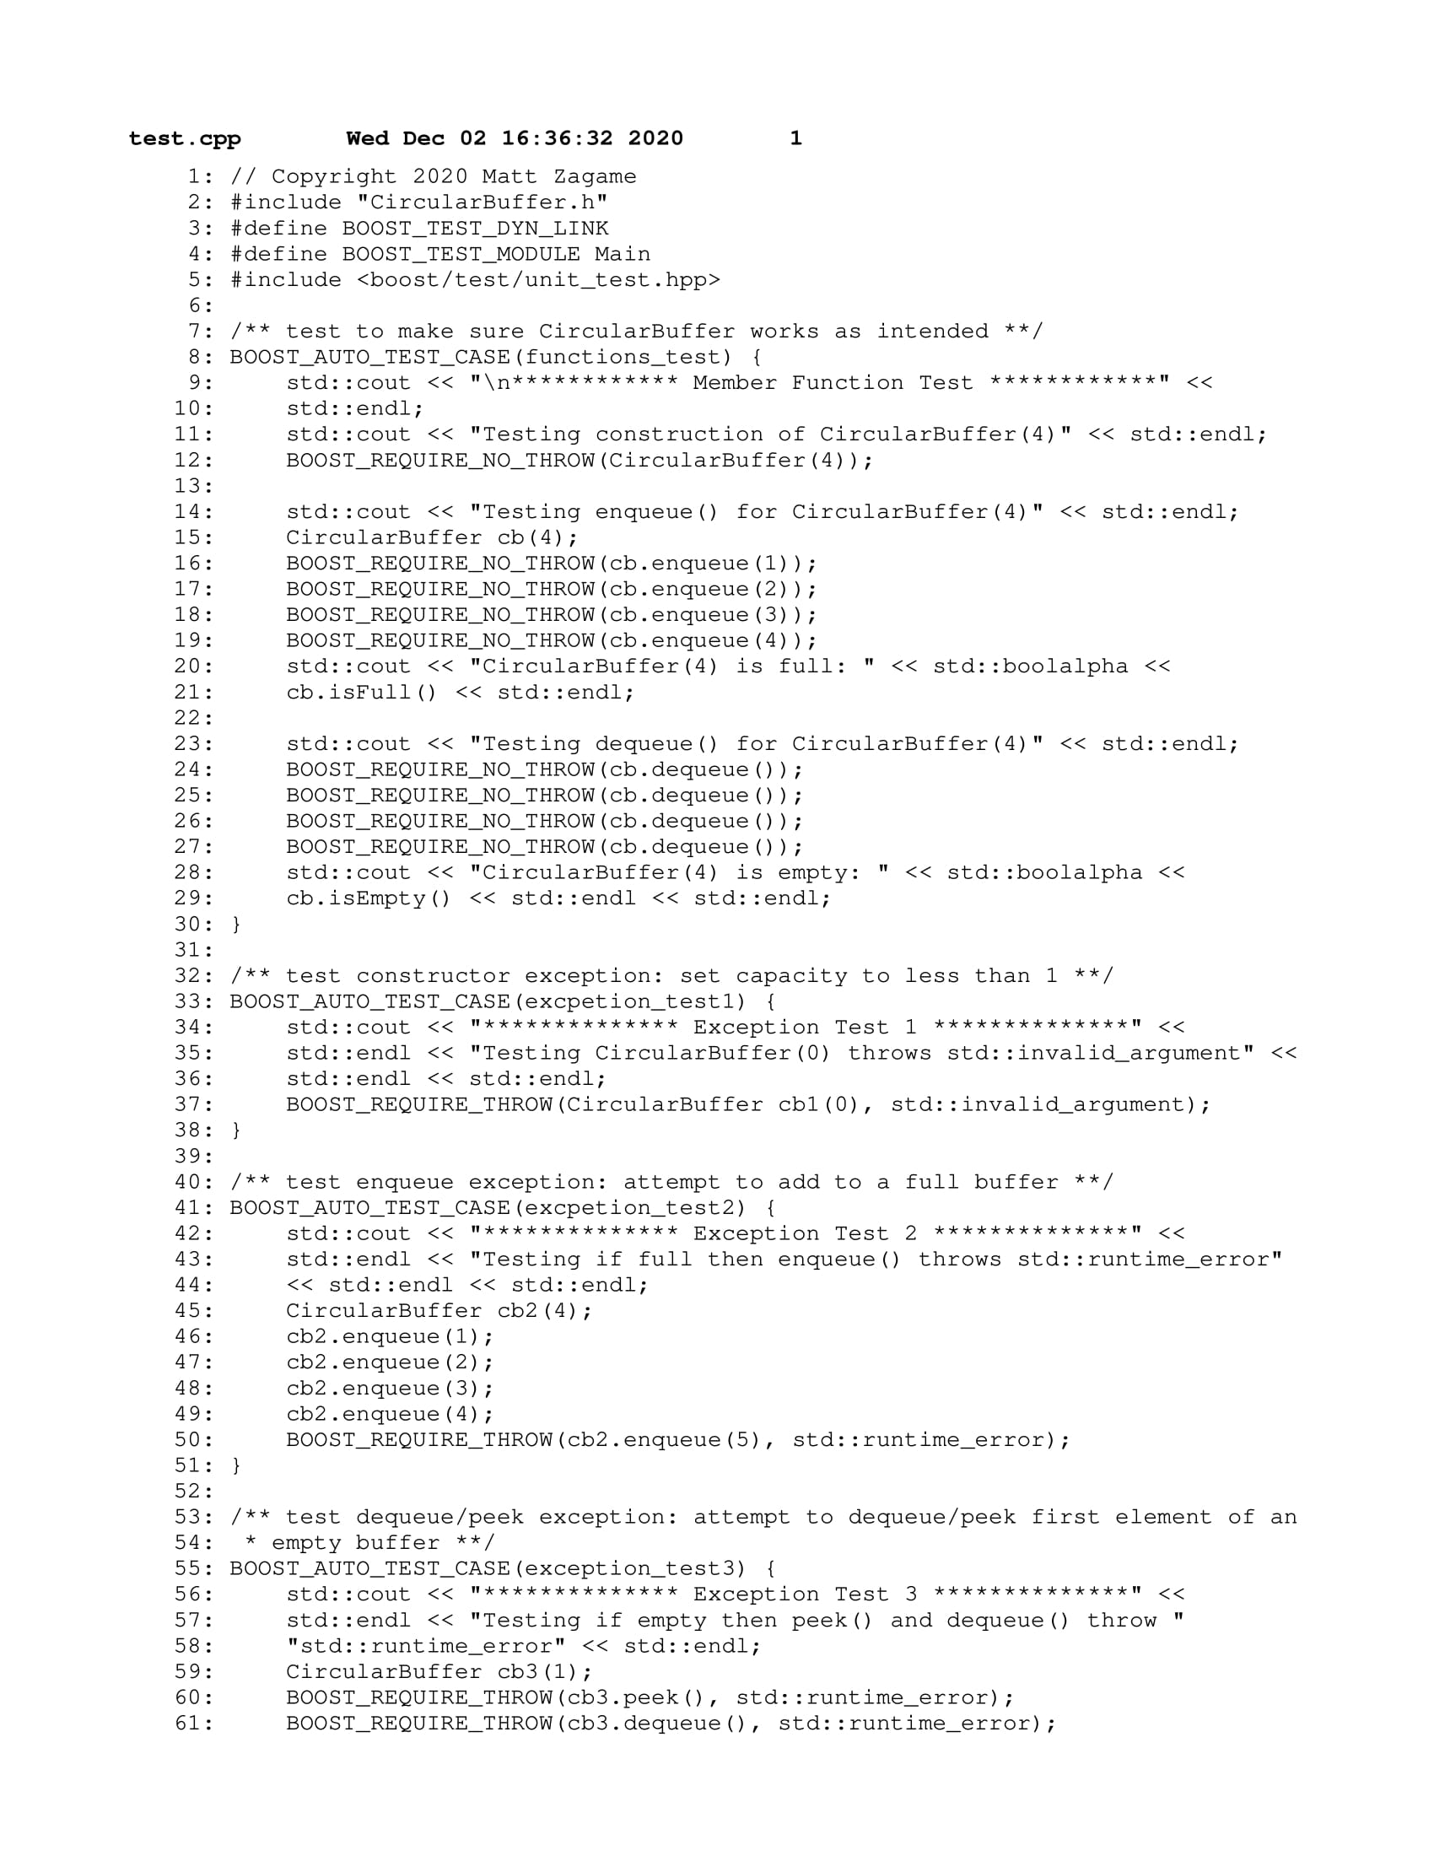

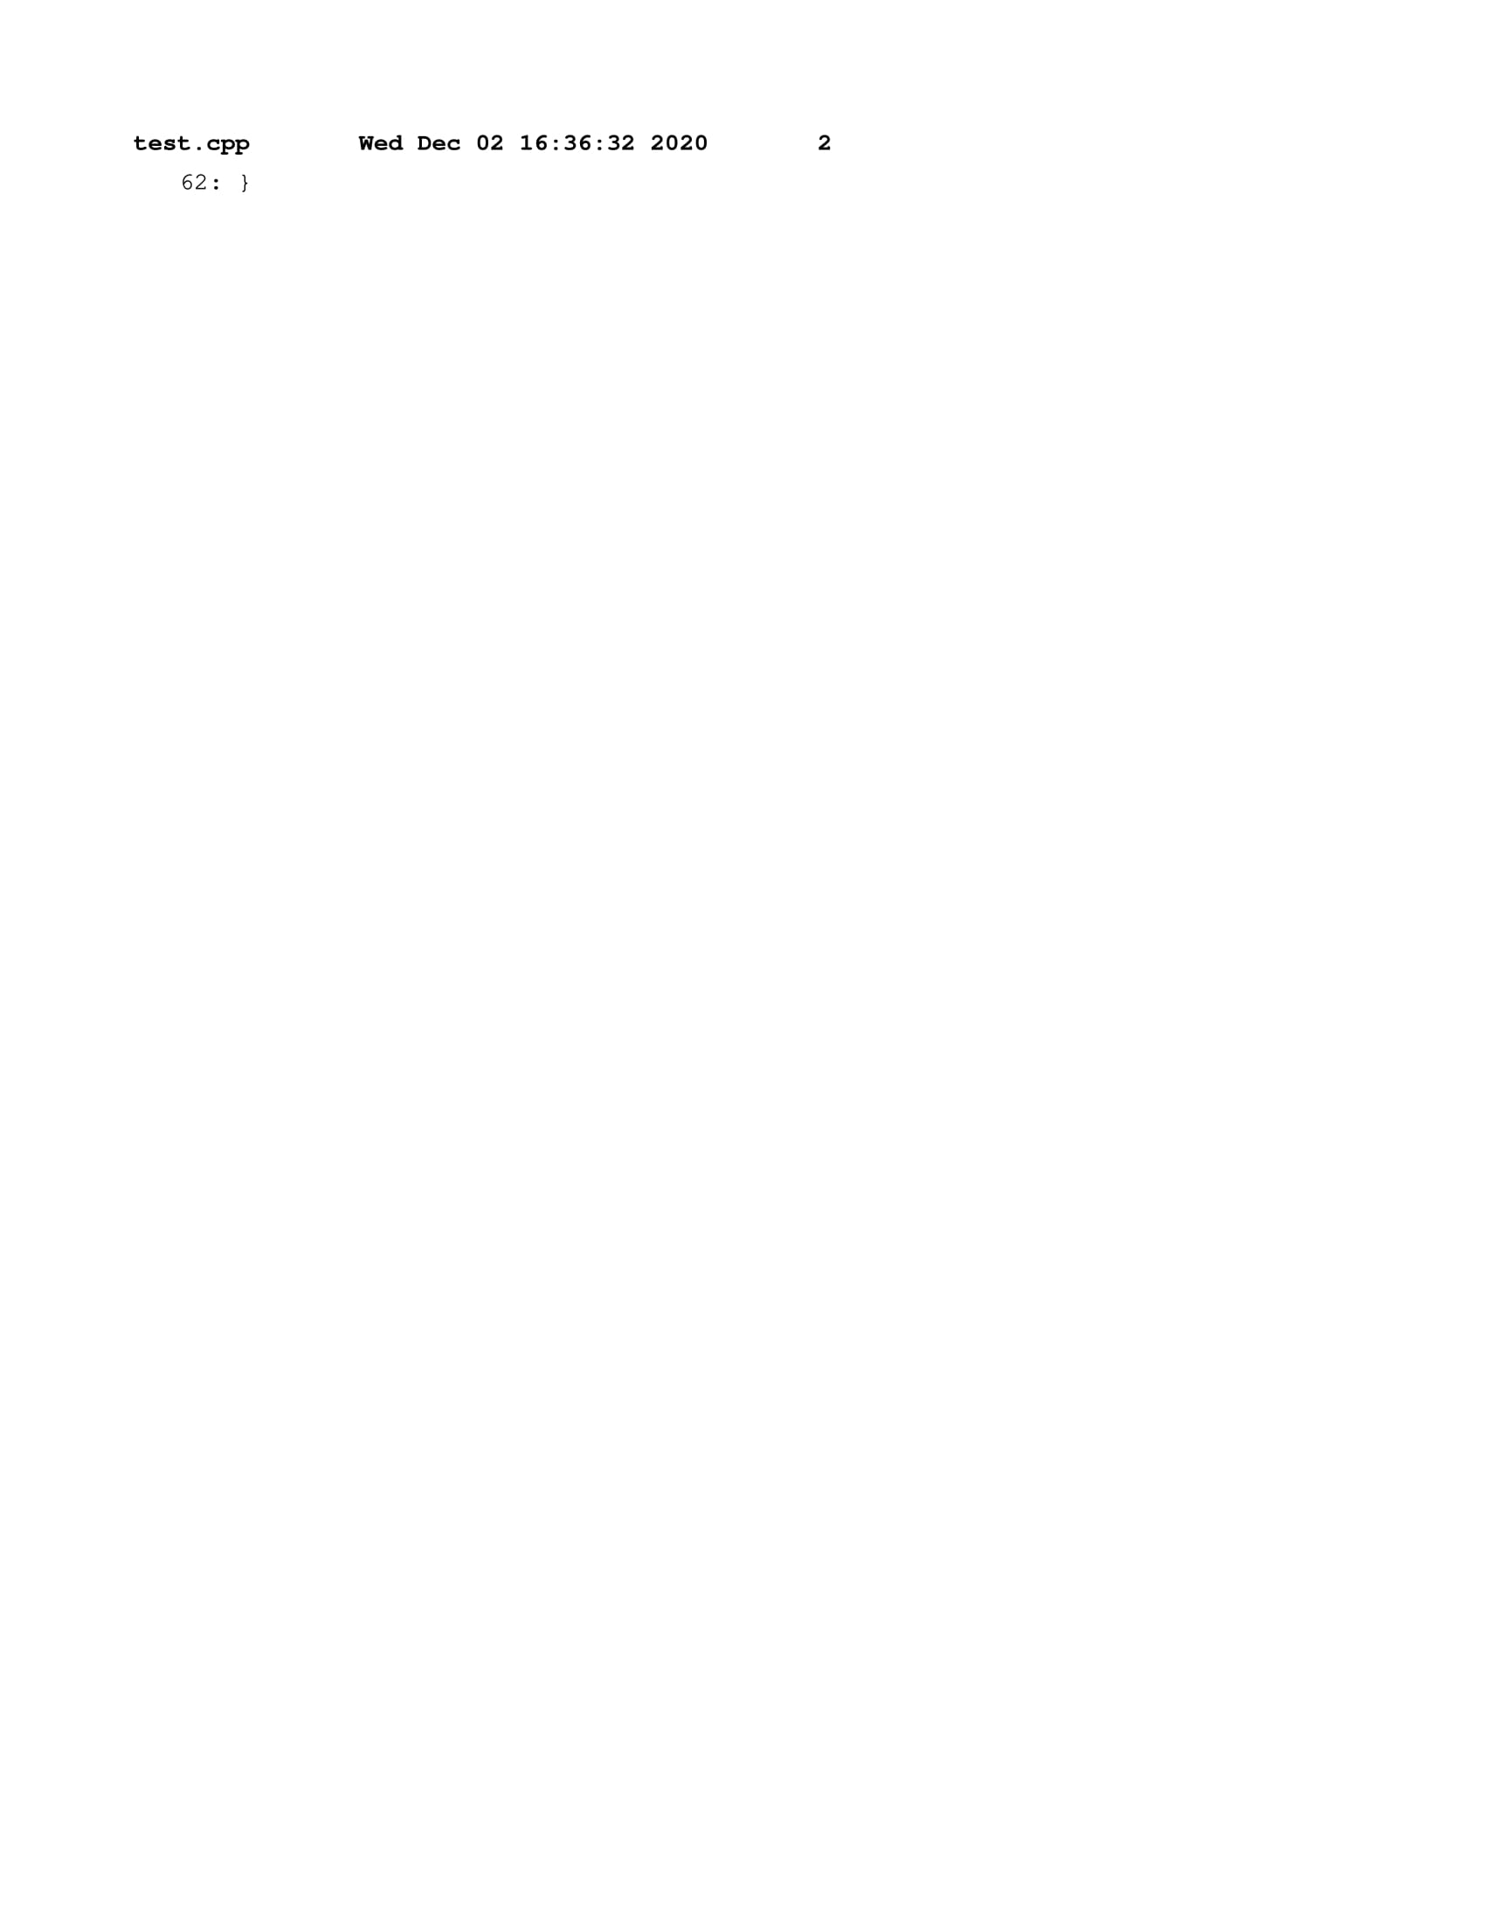

## **PS4** Edit Distance

This assignment asked us to compare two ASCII strings to compute their edit distance and to perform space and time analysis on the program during runtime. We were supposed to write a program that would compute an optimal sequence alignment on two DNA sequences using a dynamic programming approach. We could then use a programming tool known as Valgrind to measure the space complexity of our program.

**What I Did:**

My edit distance algorithm uses the dynamic programming approach of filling up a matrix with each calculation from bottom right to top left, resulting in the optimal distance at position [0][0]. The alignment path is also displayed by tracing the matrix in reverse order from top left to bottom right. The dynamic programming approach allows for the calculations of the alignment to be broken up into subproblems and then stored, instead of calculating the same subproblem several times.

**Key Algorithms, Data Structures, and OOP Designs:**

The ED (Edit Distance) class uses a vector of vectors of type int to represent a matrix of integers. The function optDistance() would then fill up the matrix from bottom to top with the minimum of three distances using the min() and penalty() functions, then return the optimal distance of the two sequences. The alignment() function would then traverse the populated matrix in reverse order and build the output alignment string based on the optimal path.

**What I Learned:**

Aside from the many applications of Edit Distance, I learned about the benefits of dynamic programming which, when compared to the recursive solution for this assignment, would have had a much higher space complexity due to the number of recursive calls exceeding 2N when comparing two strings of length N. I also learned about how to effectively monitor program memory use using the Valgrind massif tool. This tool reports how much memory was used by the heap during execution. By applying the doubling method, I was able to calculate the estimated run time and memory use of a larger sample of strings of length N.

### Makefile

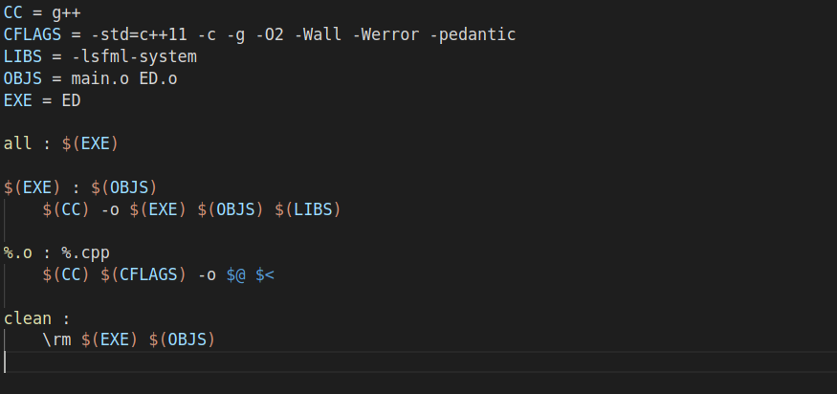

### ED.h

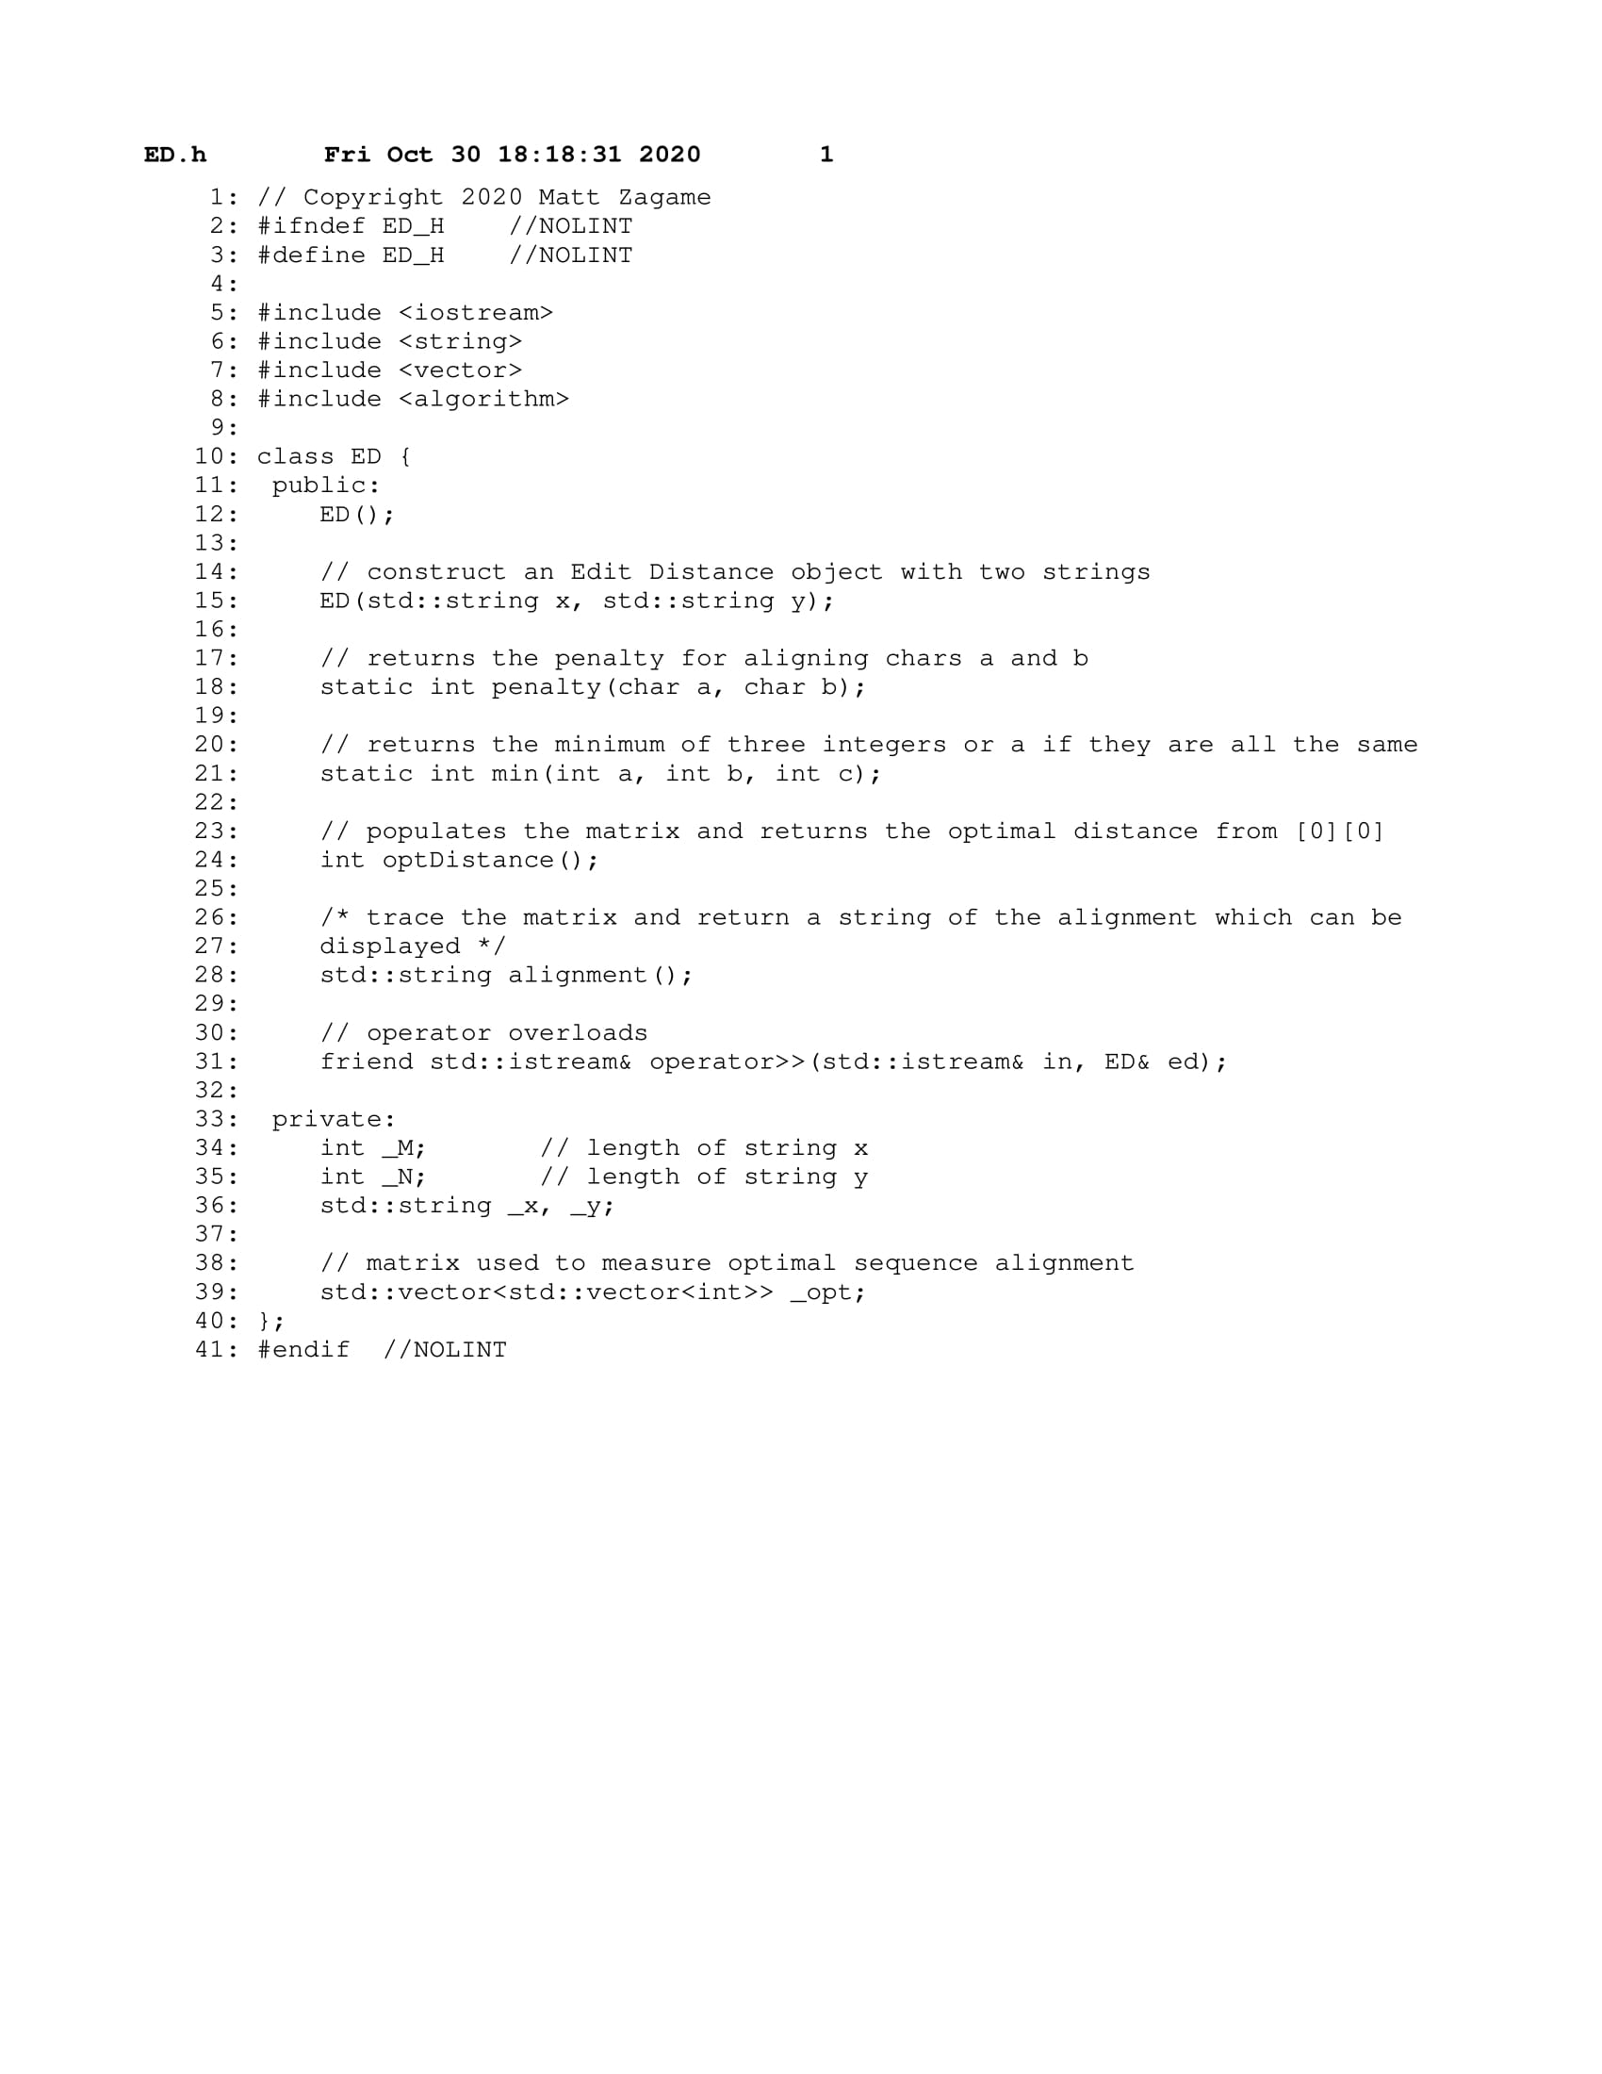

### ED.cpp

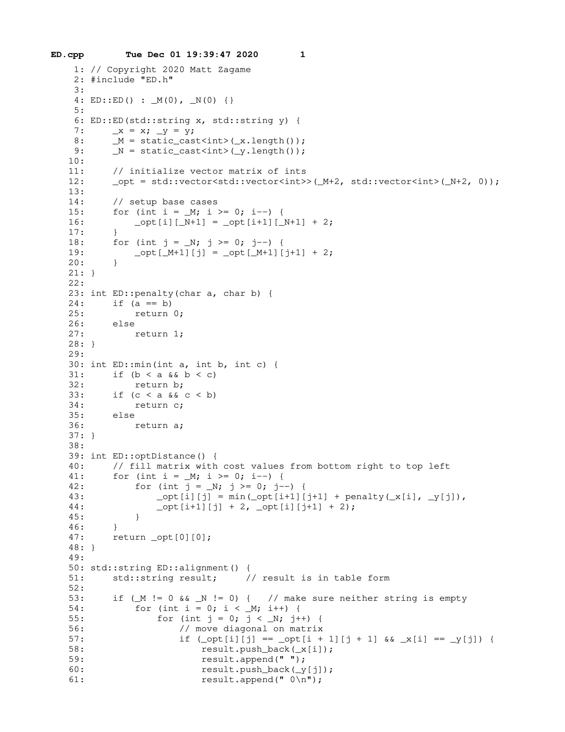

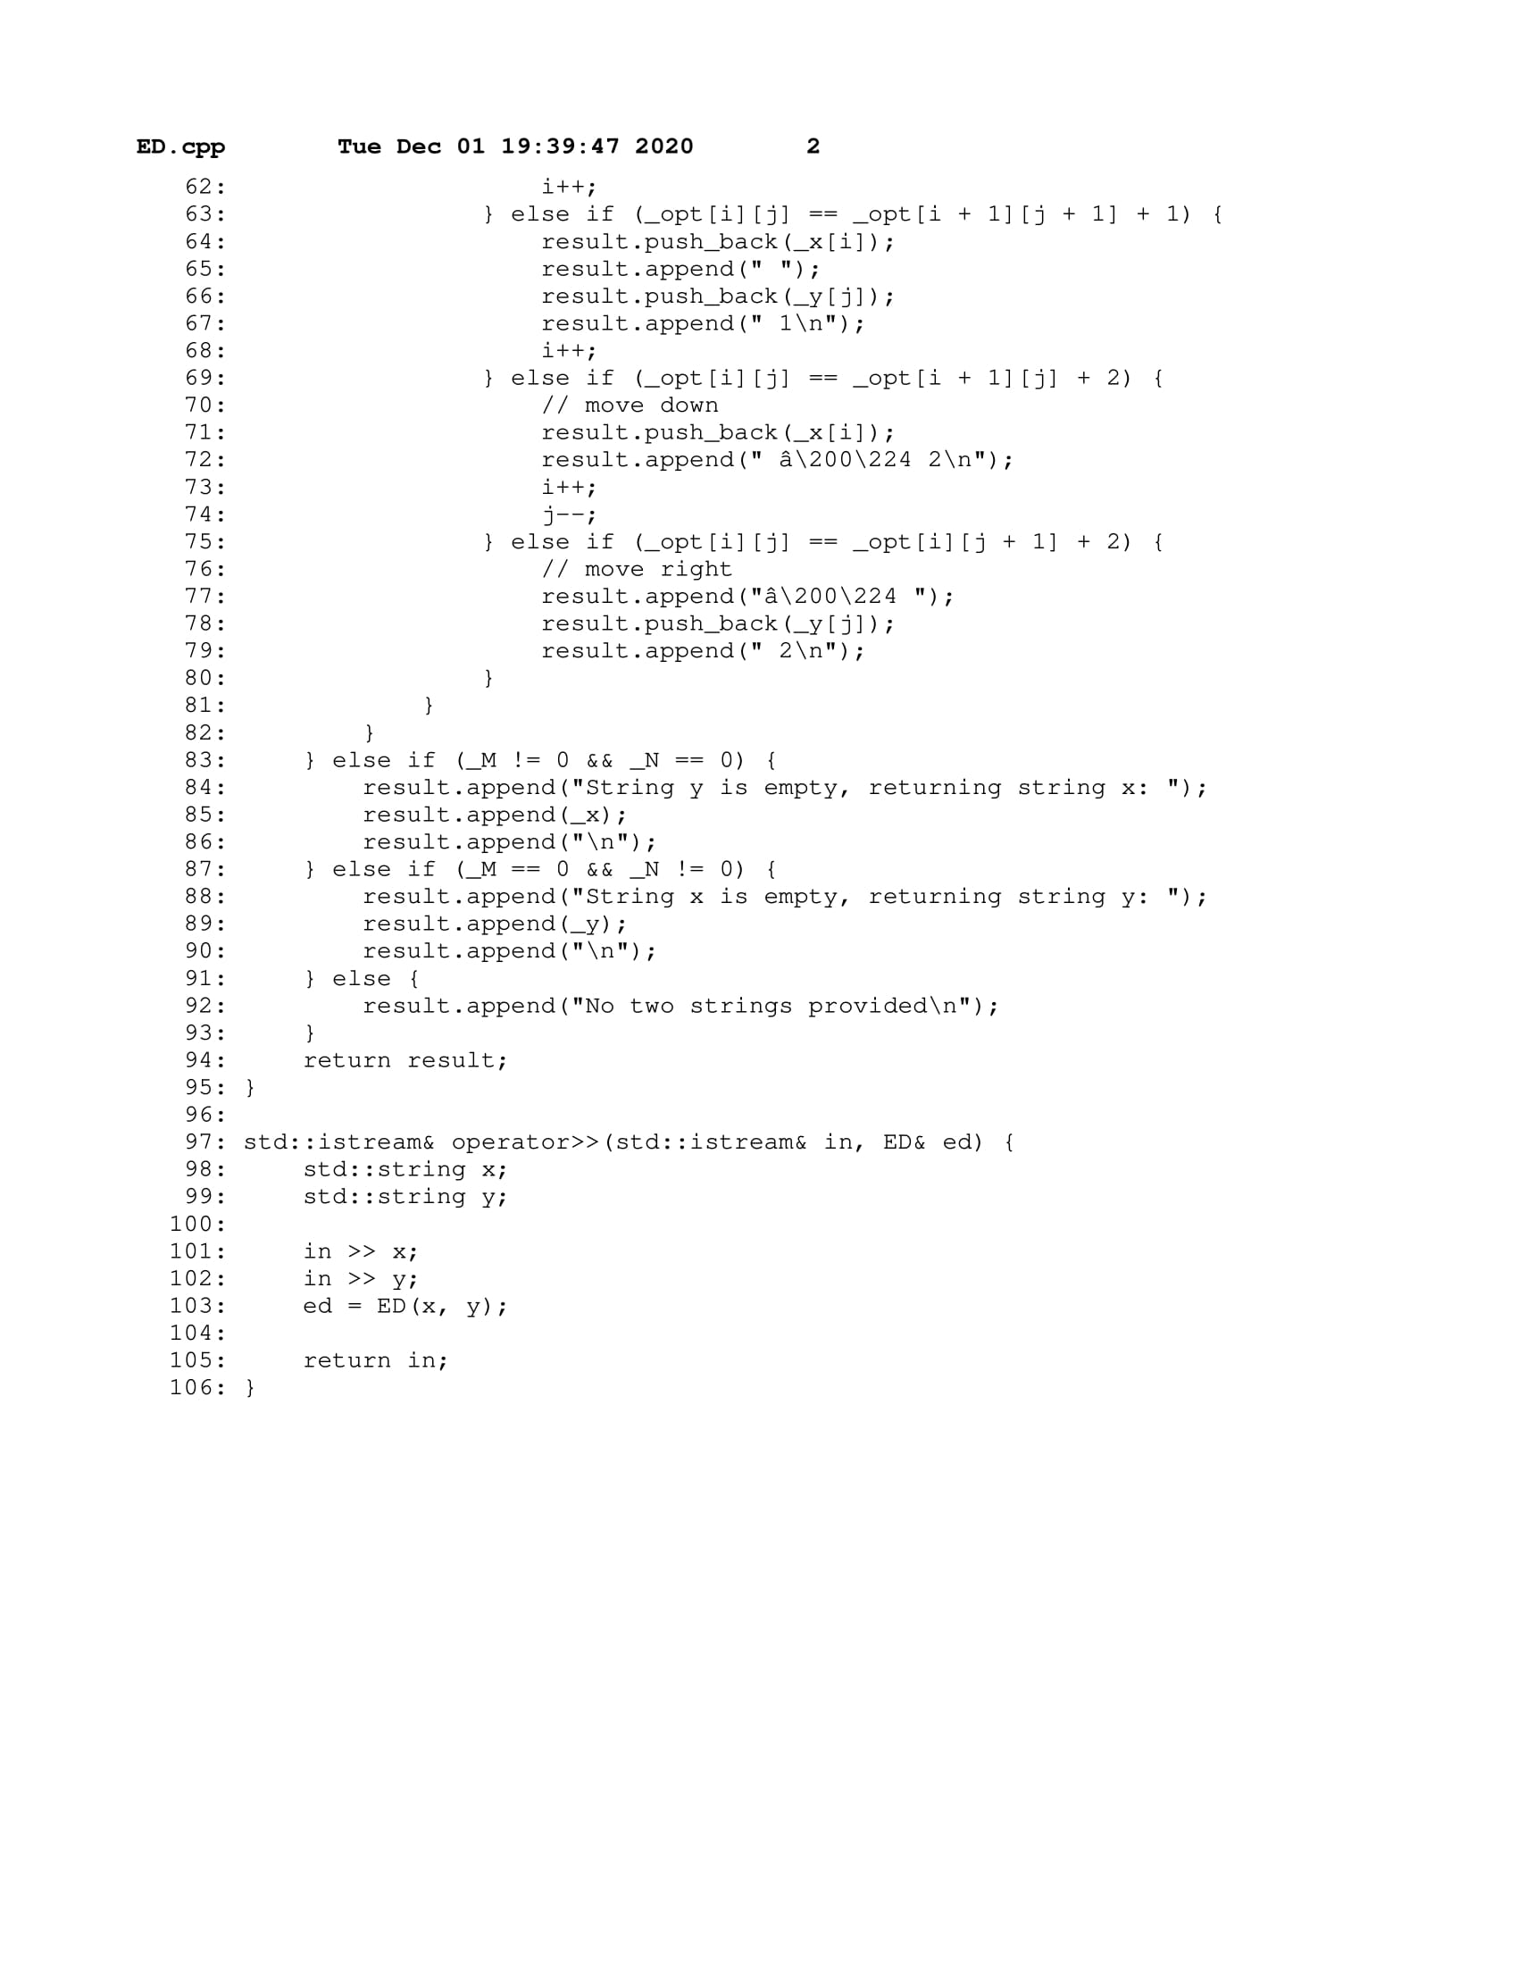

### main.cpp

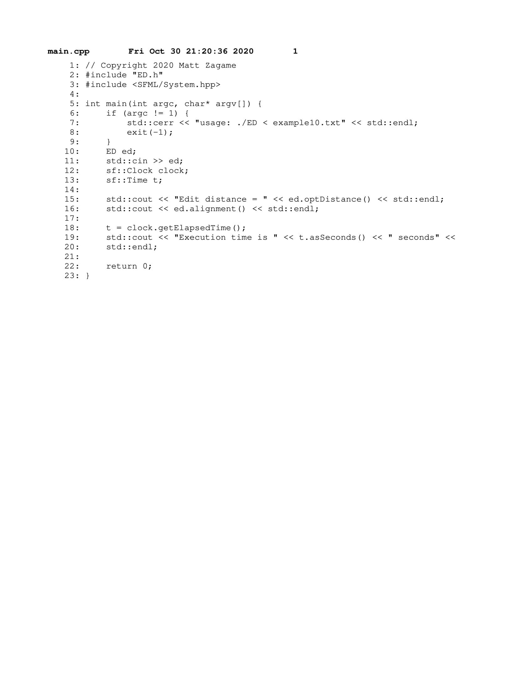

## **PS5** Markov Model of Natural Language

In this assignment we were tasked with creating a program to represent a Markov chain that can analyze k-grams (a fixed number of characters) and keep a record of the probabilities of each character’s occurrence. The program would then generate text using a Markov chain of given order k and any input text.

**What I Did:**

The Markov Model uses probabilistic analysis on text to determine the next character(s) in a sequence of k length words called k-grams. The MModel class takes a string and order k as input and maps each kgram in the string to each character following that kgram and it's frequency. The class can then generate a new string given a kgram based on the probability of each next character. The TextGenerator class uses this string generation function to analyze words in text files and produce a pseudorandom string of length L that attempts to recreate the given text.

**Key Algorithms, Data Structures, and OOP Designs:**

The MModel class uses a map containing a kgram key and a map of characters and their frequency as the respective value. MModel also makes use of the Mersenne Twister random number generator in the kRand() function. MModel's constructor sets up a map that can be displayed as a table-like output which holds each kgram and it's frequency, each next character and it's frequency as well as probability. The function generate() uses kRand() as a helper function, which selects a random next character from a kgram string when building a new string out of previously generated characters.

**What I Learned:**

Prefacing this assignment, I learned about how Markov chains are widely used in systems such as speech recognition, information retrieval, gene prediction, web search, etc. During the assignment, I was able to see first hand how the Markov model can produce reasonable text via a trajectory through a table of probabilities of k-grams.

### Makefile

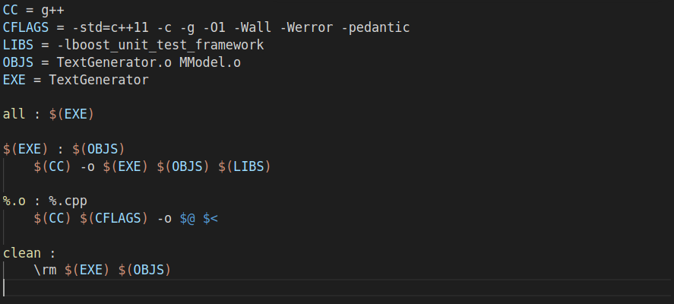

### MModel.h

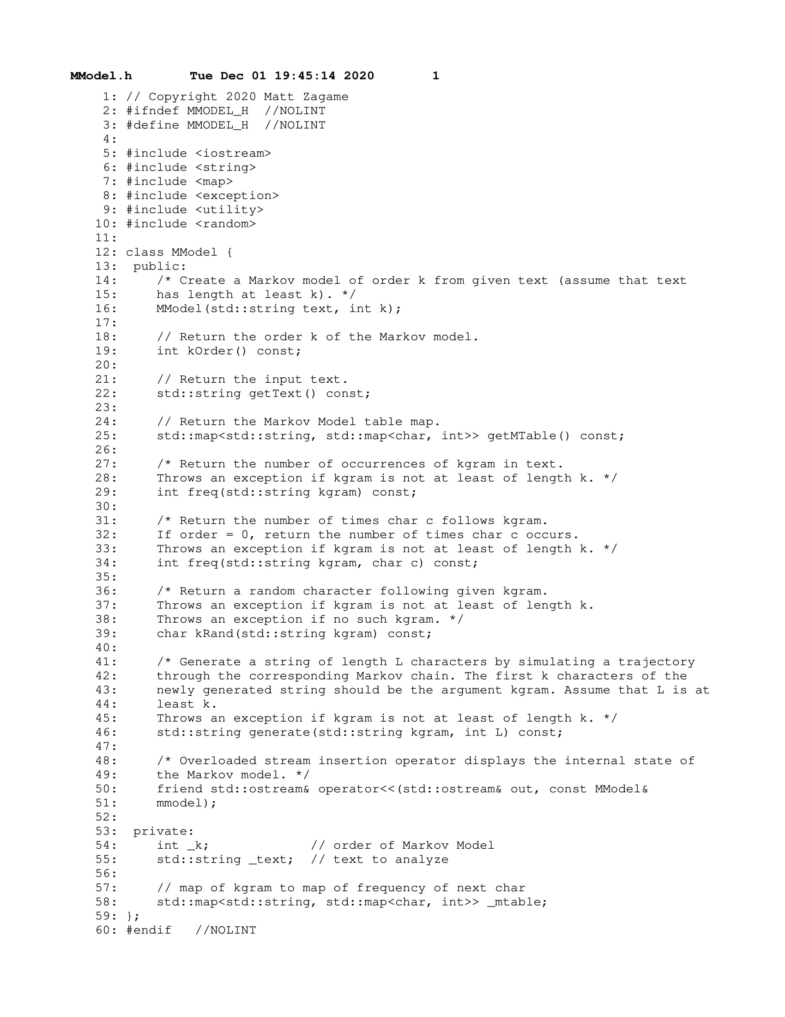

### MModel.cpp

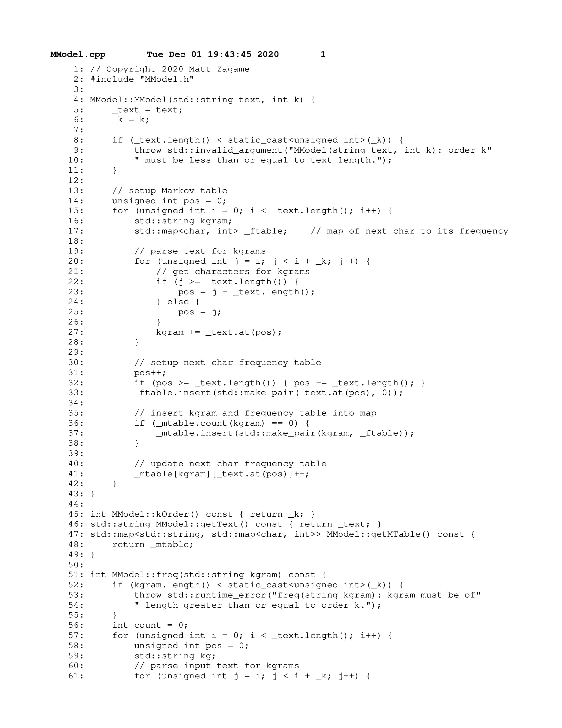

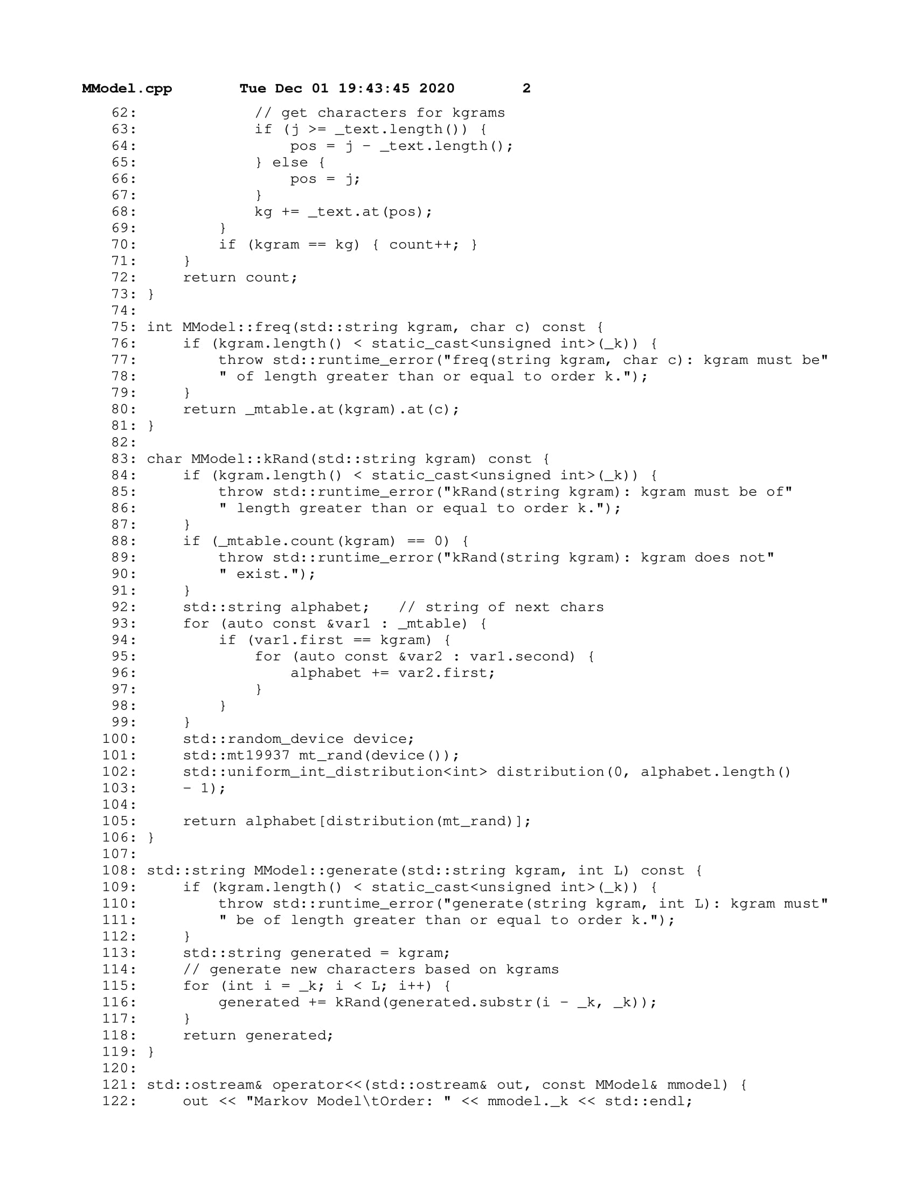

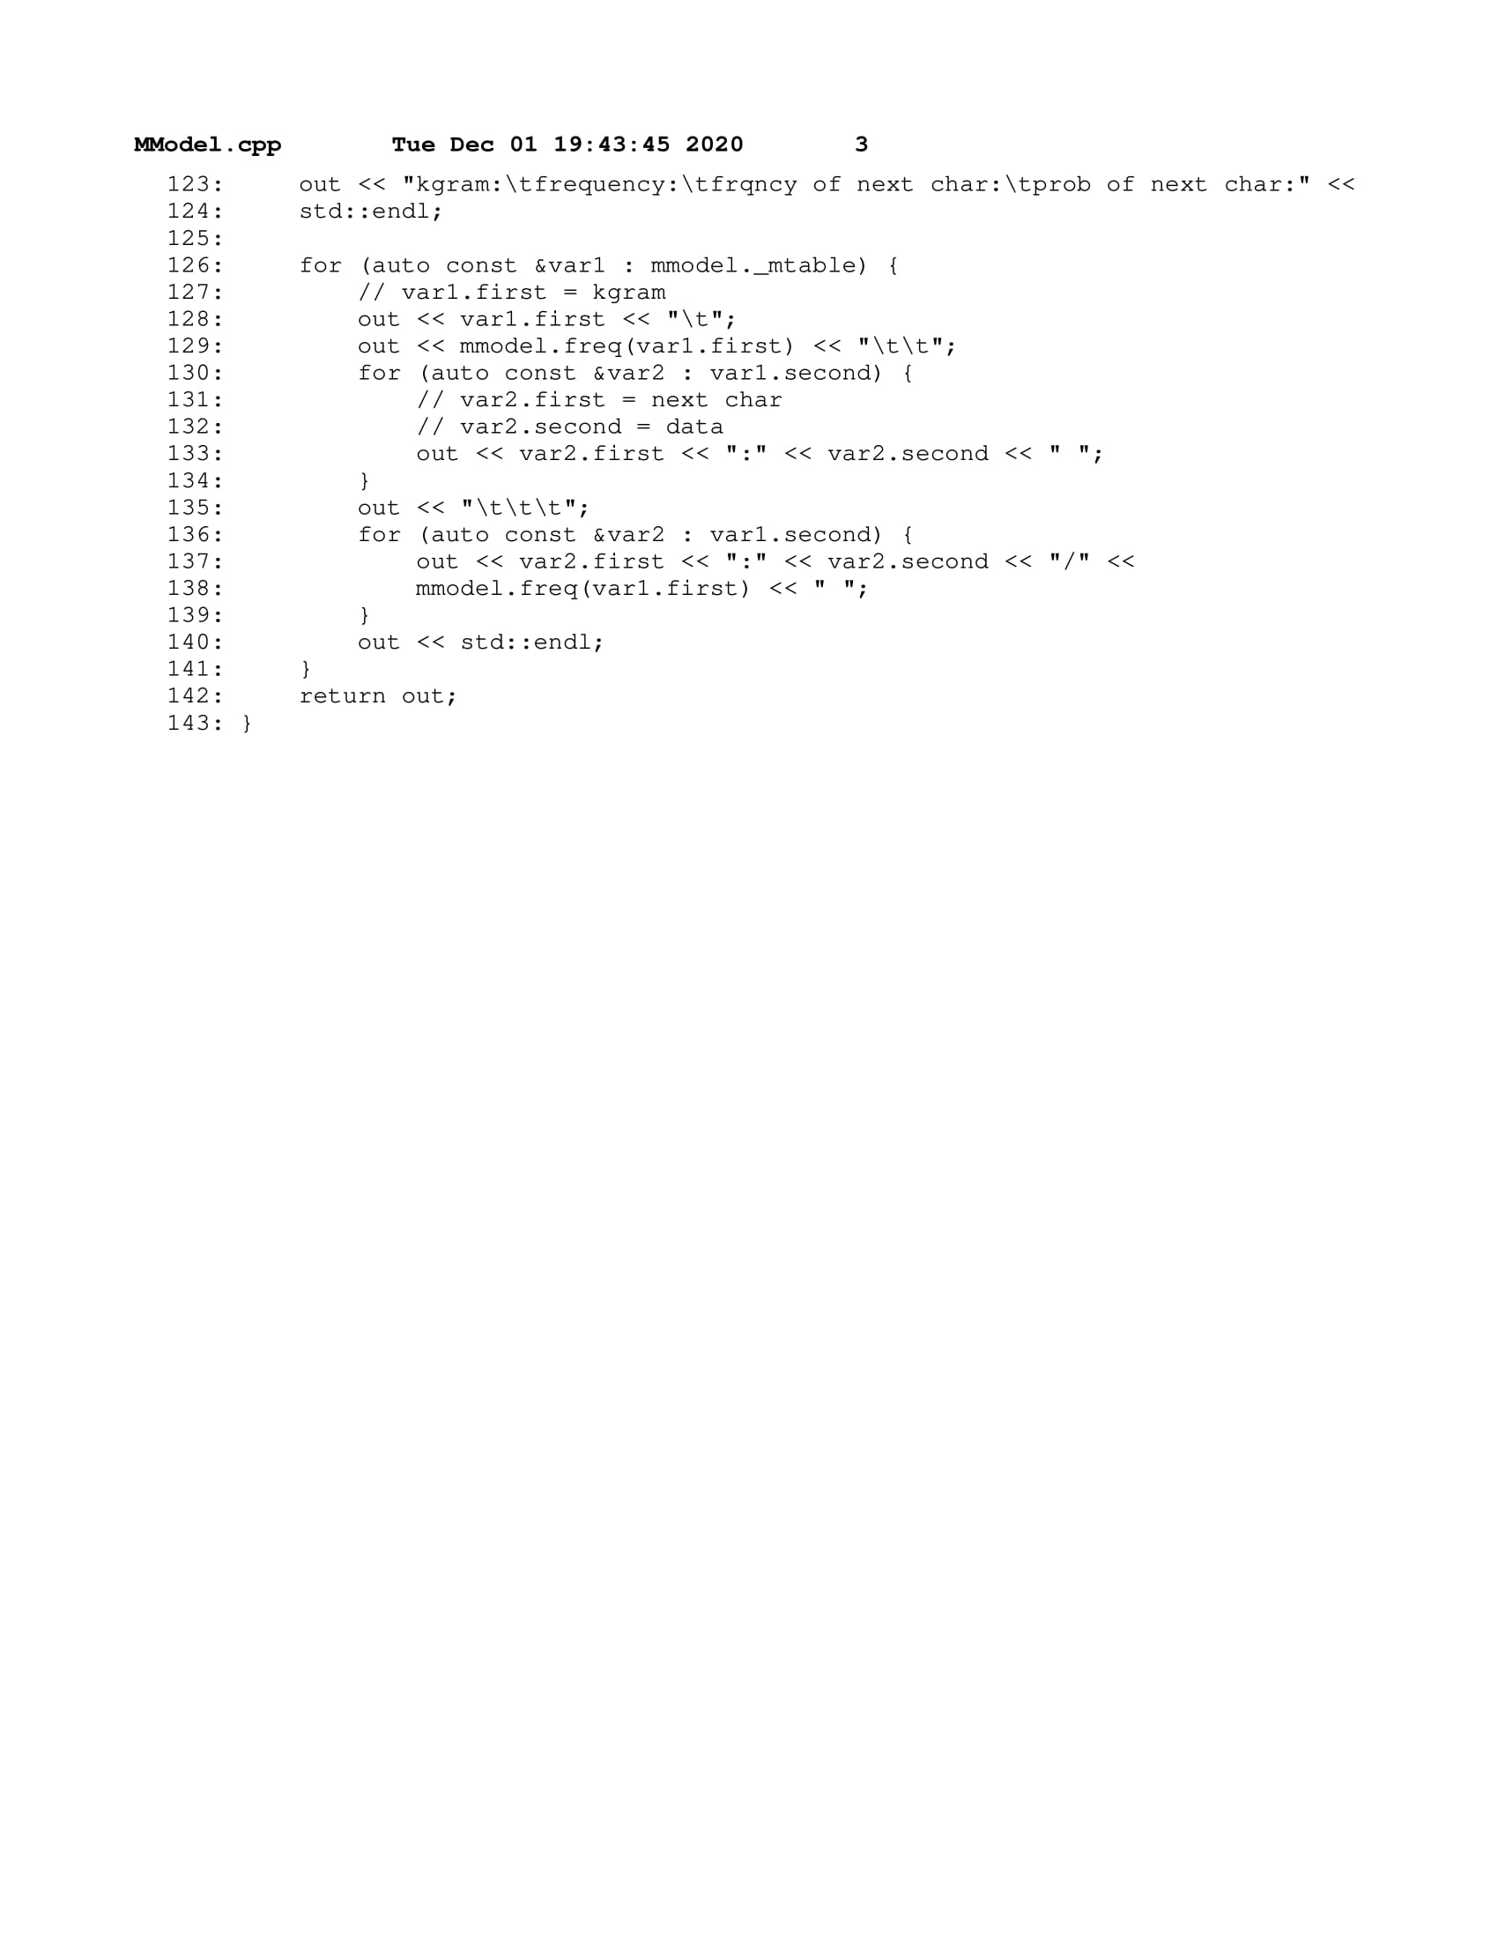

### TextGenerator.cpp

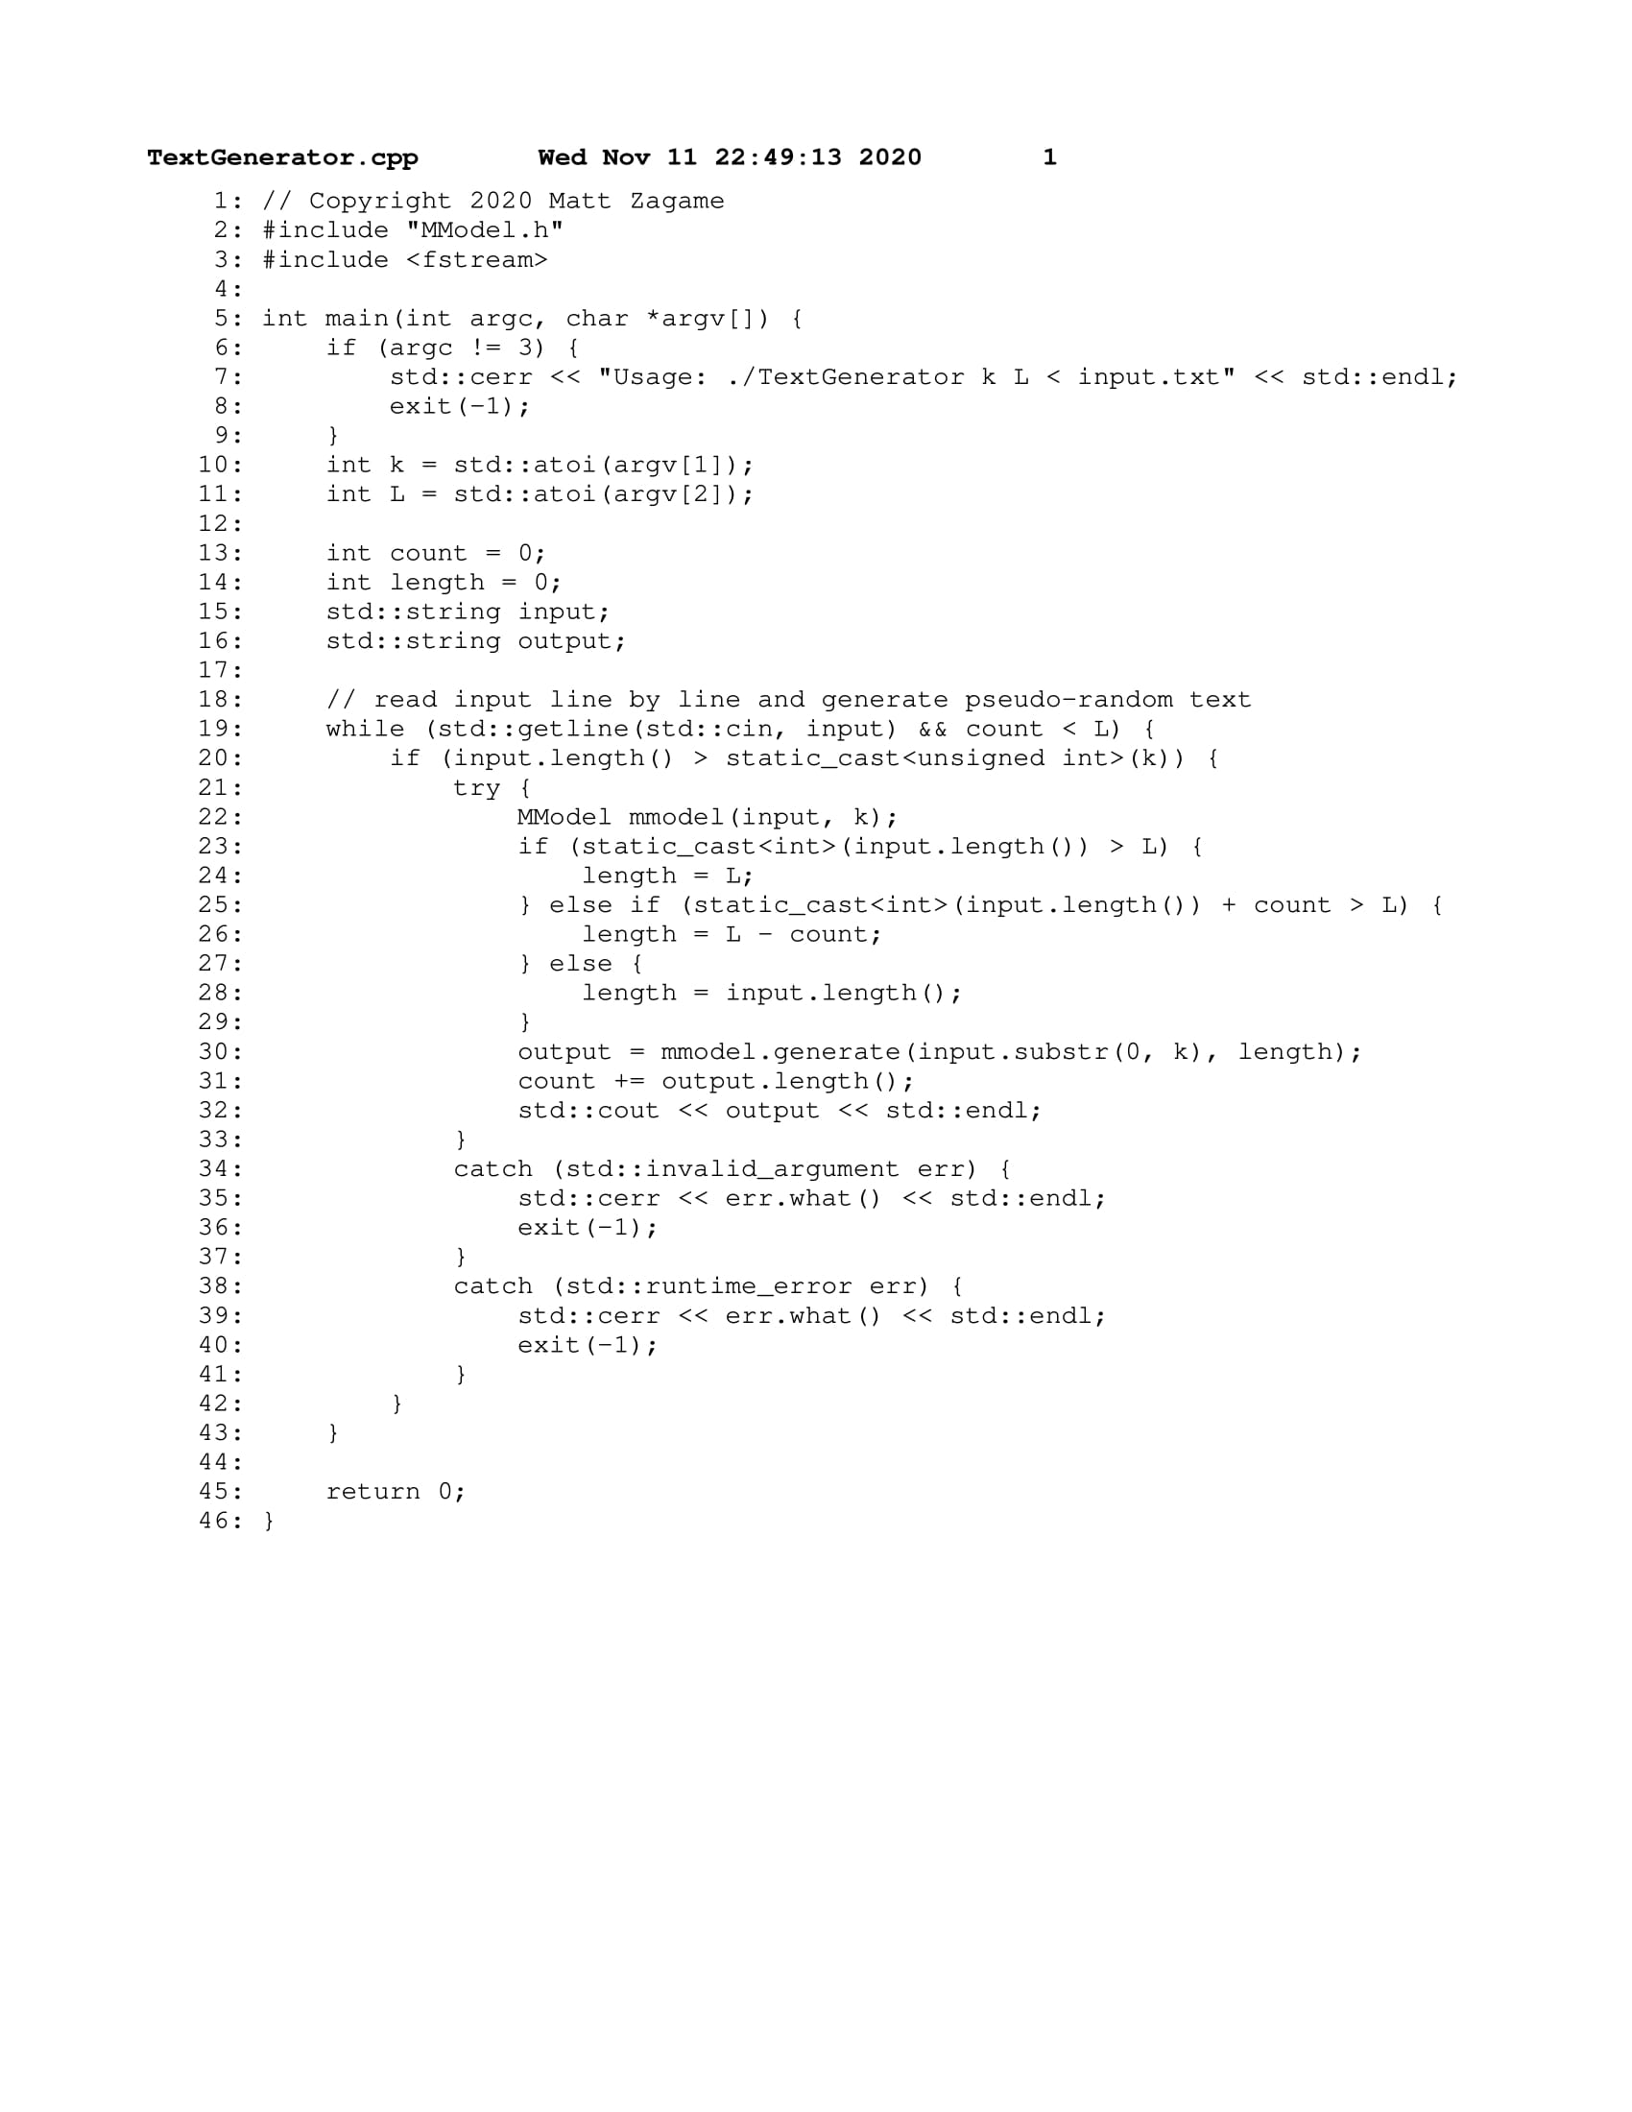

### test.cpp

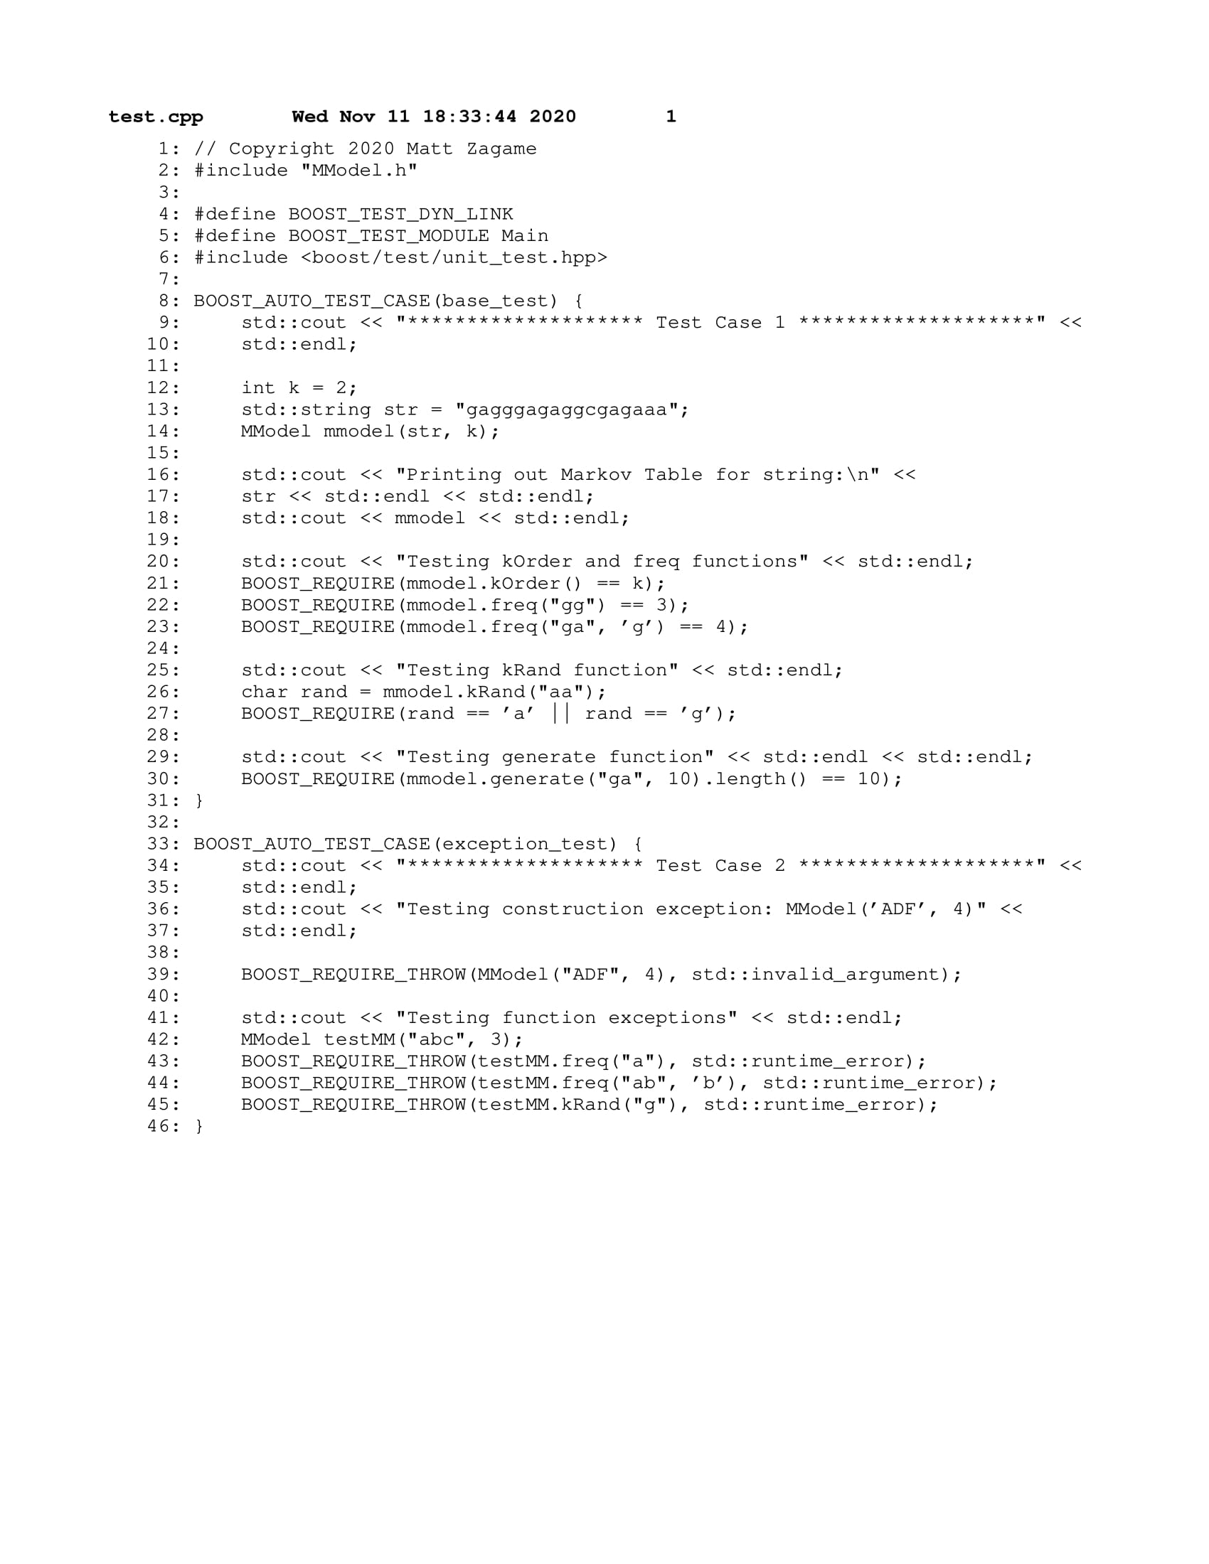

## **PS6** Kronos InTouch Log Parsing

This assignment focused on parsing Kronos InTouch time clock logs with regular expressions. Using regular expressions, we were to verify certain lines in the log and output whether a boot was successful or not in a separate file.

**What I Did:**

The program reads a log file line by line and determines whether a boot has started or completed depending on the message scanned. If it contains a boot start message then the date and time is saved and reported. Once a boot completed message is scanned, the date and time is saved again along with the total boot time from start to completion. This information is saved to a report file (.rpt) containing each successful and unsuccessful boot.

**Key Algorithms, Data Structures, and OOP Designs:**

The code for this assignment consisted of a single source file, main.cpp. I used the Boost libraries for both the regex functionality and working with the date and time. The only regex I used was for capturing the date and time reported on each boot started line or boot completed line. The actual boot messages were constant and could be scanned without the use of regex. The regex I used is as follows:

"^\\d{4}[-](0[1-9]|1[012])[-](0[1-9]|[12][0-9]|3[01])\\s\\d{2}[:]\\d{2}[:]\\d{2}"

**What I Learned:**

Although this assignment was not a lengthy one, I learned the importance of regular expressions and how they can be useful when looking to scan for or extract string/character data. I also learned how to use the Boost date/time library to get the total boot time between the boot start and boot complete events in the log.

### Makefile

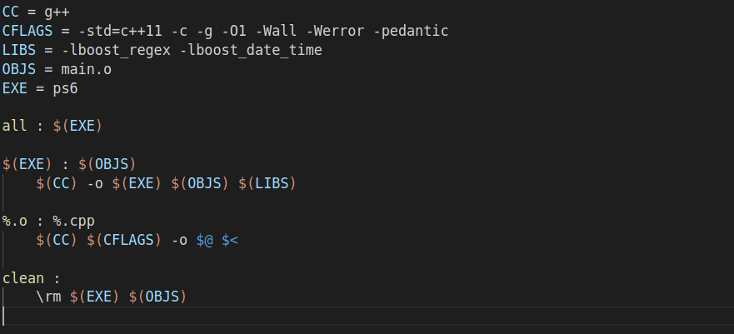

### main.cpp

